PARTNERSHIP REPORT

TVET needs of technicians and engineers in the sector of Machine Building and Mechatronics

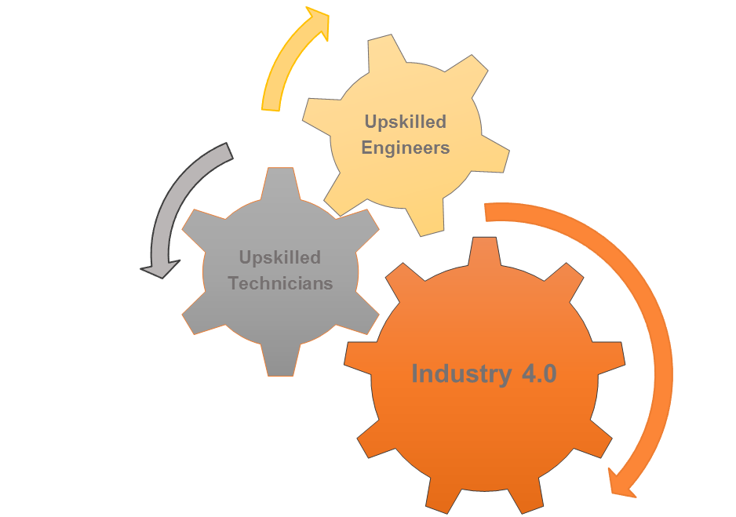

2021
Table of Contents

1. INTRODUCTION 3
2. CURRENT SITUATION IN PARTNER REGIONS 4
2.1. Gabrovo Region (Bulgaria) 4
2.2. Plovdiv Region (Bulgaria) 8
2.3. EAST MACEDONIA AND THRACE (GREECE) 12
2.4. POMORSKIE REGION (POLAND) 16
2.5. Niš Region (Serbia) 22
3. ANALYSIS OF RESULTS BY REGION 26
3.1. GABROVO REGION (BULGARIA) 27
3.2. Plovdiv Region (Bulgaria) 32
3.3. EAST MACEDONIA and THRACE (GREECE) 37
3.4. POMORSKIE REGION (POLAND) 42
3.5. Niš Region (Serbia) 47
4. CROSS-REGION ANALYSIS 51
4.1. Partnership regions covered 51
4.2. Share of engineers and technicians from total number of employees in the region 53
4.3. Opportunities for professional training of technicians and engineers 53
4.4. Opportunities for validation of non-formal learning 53
4.5. Training needs 54
4.6. Training needs related to soft skills 58
4.7. Training methodology 58
5. CONCLUSIONS 60
ANNEX I 62

INTRODUCTION
The present Report is written within the ERASMUS+ Programme, KA2, project Active Learning Community for Upskilling Technicians and Engineers (allCUTE). It is based on a survey carried out among 161 companies in the sector of Machine Building and Mechatronics so as to identify the needs of technical and vocational education and training of their technicians and engineers. It covers 5 partner regions:
- Gabrovo region, Bulgaria;
- Plovdiv region, Bulgaria;
- East Macedonia and Thrace region, Greece;
- Pomorskie Region, Poland;
- Nis region, Serbia.
The Report is developed in the context of the demands of Industry 4.0 imposed on today’s technicians and engineers. The 4 key elements of Industry 4.0 : Internet of Things, Big Data and Analytics, Engineering Simulation and Additive Manufacturing have a significant impact on machine building and mechatronics since they require complete redesign of processes and operations to accommodate those new advancements. Therefore, those industries need forward-thinking technical and engineering staff who can embrace these digital tools and technologies so as to design, repair and maintain the increasingly smart manufacturing facilities. To do that, companies are aware that they should invest in the training of those employees so as to continuously improve their competence and skills in order to achieve excellence and meet the new demands of both manufacturing and customers.
This Report aims to:
- present the current situation of the partner regions in relation to TVET provision to technicians and engineers employed in the sector of Machine Building and Mechatronics;
- identify the training needs of the companies in the respective sector by partner region so that they can improve the competence and performance of their technical and engineering staff;
- identify the teaching methodology preferred by the employers;
- compare survey findings across partner regions;
- give recommendations for the elaboration of the follow-up curriculum.

CURRENT SITUATION IN PARTNER REGIONS

Gabrovo Region (Bulgaria)
2.1.1. Brief description of economy
The economy in the Region of Gabrovo is predominantly driven by the industrial sector. In 2018 the value of the produced goods was almost 2.5 billion BGN with over 1.6 billion BGN of which - generated by the production industry. The processing industry has a major share in the overall economy of the region and constitutes about 60% of the total production, twice the average at a country level. Manufacturing of machinery, equipment and fabricated metal products has a leading role in the processing industry with the highest added value per employed person. Almost half of the income generated by the industry in the region comes from the above mentioned manufacturing. The Region of Gabrovo is also the main hub for the production of tools for the machine building industry with more than 20 companies operating in this field. Gabrovo plays a leading role in the hoist building; some of the biggest electrical hoists building companies in Bulgaria are located in the region. They operate in a cluster model under the name “Podemna Tehnika” including also companies from the neighbouring Veliko Tarnovo region. Other areas of the industry in the region include the manufacturing of production lines for the production and filling of tubes (Mehatronika AD), controllers for CNC machines (AMK Drives and Controls), simulators for Formula 1 (RSeat), etc. Production facilities of: Ideal Standard (sanitary ware) employing more than 3,500 people; ABB Power Grids Ltd. – producer of elements for power supply systems, etc. are located in the town of Sevlievo.
Economic centre “Gabrovo-Sevlievo” having a strong industrial profile includes the municipalities of Gabrovo and Sevlievo. It is rated among the 20 most important economic centres in Bulgaria. The industry of the region is predominantly export-oriented with more than 50% of all goods produced being exported. For the machine building industry products the export rate is even higher – about 66%.

2.1.2. Share of engineers and technicians from total number of employed in the region
The total number of employees in Gabrovo region is about 39,000 - approximately 50% are employed by companies from the processing industry. About 40% of all employees work in the field of machinery, equipment and fabricated metal products manufacturing. There is no official statistical data about the educational profile of the people employed by these companies but some justifiable assumptions can be made using other statistical data publicly available:
Relative share of the population between 24 and 64 years holding a higher education degree – 27,9%;
Relative share of the population between 24 and 64 years holding a secondary education degree – 57,6%.
At least 2/3 of all personnel employed in the machine building and electrical engineering companies has a technical degree (engineers and technical staff) or hold positions which require such a degree.
Based on the above stated, it would be a fair assumption to make that at least 7,000 of all employees in Gabrovo region have a technical degree and approximately 2000 of them have a degree in Engineering.

2.1.3. Education and Learning Opportunities
      - Formal Learning. Educational institutions offering upskilling courses for engineers and technicians.
- Higher Education
The Technical University of Gabrovo offers engineering degrees (bachelor, master and PhD) in the Faculty of Mechanical and Precision Engineering and the Faculty of Electrical Engineering and Electronics. It is the main source of engineers in the region.
- Secondary Education
About 50% of all students in secondary schools pursue vocational training and more than 60% of them study technical subjects. The business and the educational institutions in the region work in collaboration to plan the programmes to be offered in the secondary schools so as to give students better employment opportunities after graduation and to meet the demands of the business on the labour market.
- Vocational training opportunities funded by the Government and/or by EU Funds
Employed personnel can take advantage of two options for vocational training funded by the EU:
Under Operational Programme “Human Resources Development” any employed person holding a secondary education degree or lower is eligible to apply for a vocational training course to obtain a new qualification or additional key skills and competencies (e.g. foreign languages). 85% of the training is funded by the Programme. Each employee can independently choose the qualification or skills he/she is interested in and no consent or approval is needed from the employer. Operational Programme “Human Resources Development” is running for a second period. The majority of the beneficiaries choose to study foreign languages and very few opt for technical trainings, the only exception being the profession of an automotive technician, which includes a driver licensing module.
Vocational training for the employees as part of a broader project to renew the equipment in the company. Such trainings usually come with very little funding and is limited to training the employees on the usage of the new equipment delivered as part of the project.
Funding of projects which include preliminary selection of unemployed people, vocational training provided at site by a vocational training centre and/or a mentor and consecutive job placement. These projects are very few in number and for the most part the trainees are only trained on a subset of modules for a given profession. The main goal of these projects is to provide basic knowledge of unemployed people in a certain professional filed. On an annual basis no more than 100 unemployed people undergo such trainings, some of them with technical subjects. Trainings in the field of engineering are not offered in this type of projects.

      - Informal and Non-Formal Learning – specialized workshops, on-the-job trainings, etc.
In addition to formal learning, there are also the so-called informal and non-formal learning.
Non-formal learning takes place outside formal learning environments but within some kind of organisational framework. Informal learning takes place outside schools and colleges and arises from the learner’s involvement in activities that are not undertaken with a learning purpose in mind.
Non-formal learning is initiated by the company itself and is available for the employed staff. The actual training can be delivered either internally by the company or by Employers’ Organisations or by Vocational Training Centres. This type of non-formal learning initiatives is predominantly targeting the development of key competencies of the personnel. In some more rare cases the goal is to raise the vocational qualification of the employee mainly in the field of IT.

      - Possibilities for validating knowledge and skills of engineers and technicians
Validation is the process of assessing, recognition and officially documenting the correlation between skills, knowledge and competencies gained through non-formal and informal learning and national educational standards and requirements for gaining a professional qualification.
The regulation on conditions and procedures for validating professional knowledge, skills and competences came into force in January 2015.
Validation is the process of assessing, recognition and officially documenting the correlation between skills, knowledge and competencies gained through non-formal and informal learning and national educational standards and requirements for gaining a professional qualification and guarantees better access to vocational training and the labour market. However, only qualifications in professions and specialities included in the list of professions for vocational education and training (VET) can be validated.
Institutions entitled to carry out validation include: VET schools, vocational gymnasiums, art schools, sports schools, vocational colleges and VET centres.
Validation includes procedures for identifying professional knowledge, skills and competences acquired, and provides two types of certification:
- certificate for validating level of vocational qualification: following an exam, it certifies that all learning outcome units defined in the State educational requirement have been achieved;
- certificate for acquiring a vocational qualification for part of a profession: following an exam, it certifies that one or several learning outcome units included in the State educational requirement have been achieved.
Holders of these certificates have the same rights as those who have attained corresponding certificates through the formal education system.
There is no such established system for validating the skills and knowledge of engineers.

Plovdiv Region (Bulgaria)

    - Brief description of the economy of Plovdiv region
Plovdiv is the number 1 industrial center in Bulgaria. The total production is about BGN 17.5 billion in 2018, and that in industry is nearly BGN 9.5 billion. The structure of the local economy is strongly dominated by manufacturing, which, according to NSI data, occupies 39.9% of it (relative to value added), which is 12% more than the second largest sector. In relation to the produced production the share of the production is 55 percent, and in relation to the incomes from the activity it is 36.3 %.
In the Plovdiv region is located Trakia Economic Zone (TEZ) - the largest and most sustainable industrial zone not only in Bulgaria but also in Southeast Europe. It unites 6 industrial zones in the region of Plovdiv - "Maritsa", "Rakovski", "Kuklen", "Plovdiv", High-tech park "Innovations" and Agro park "Kaloyanovo". The area is over 10,700,000 square meters, half of which is already occupied. In 24 years (since the start of the first Maritsa zone in 1996), more than 3 billion euros have been invested in it.
TEZ employs over 180 companies, half of which are foreign. Enterprises related to the production of metal products, machinery and equipment, computer and communication equipment, electronic and optical products, electrical equipment and details for power supply, automation, etc. have built world leaders such as ABB (have 2 plants), Liebherr, Osram, Hanon Systems, Sensata Technologies, Biomashine, BTL Industries, Spinner, Milara International, William Hughes, Mecalit, Suit, Willi Elbe Gelenkwellen, Intrama, Aiger Group, Techno Aktas , Ataro Clima, VEM and others. The Plovdiv plant of Schneider Electric became the second enterprise of the French group in Europe, where technologies of a "smart" factory can be seen, which optimize the production through various systems for digitalization and automation. This year, the company received an intragroup smart factory certificate, making it the only demonstration center for a total of 14 countries in Eastern Europe.
TEZ is one of the most important companies in Bulgaria - KCM 2000 AD. And the machine-building "Balkancar Record" is the largest manufacturer of forklifts, electric trucks and electric platforms in Bulgaria.
Over 30 of the plants in TEZ produce various parts for the automotive industry.
The team of "Trakia Economic Zone" in 2020 laid the foundations of the Consortium "Carbon Neutral Industrial Parks" for the development of industrial zones in Bulgaria in four districts - Plovdiv, Burgas, Gabrovo and Haskovo. The strategic project, which is in line with the EU Green Deal, aims to create an attractive investment and innovation environment in the areas of the participating municipalities, reduce carbon emissions, improve working conditions and living standards. Carbon-neutral industrial parks will attract investors who rely on environmental principles in their future industrial development. The project was developed by the team of Trakia Economic Zone, using the joint work with the largest scientific community for applied research in Europe - the German Fraunhofer Institute, the United Nations Industrial Development Organization (UNIDO), the Bulgarian Investment Agency (IBA) and the successful experience of Public-private partnership with nine municipalities and three clusters.
TEZ companies themselves invest in products related to the "Green Deal", such as eco-means of transport. In 2019, in the Trakia Economic Zone, the assembly of electric trucks in Milara International with main parts made in China began for the first time in Bulgaria. Milara International considers that from the beginning of 2021 the parts of the electric trucks will be entirely Bulgarian and European production. TEZ also employs the 2 largest Bulgarian companies for the production of electric bicycles - Maxcom and Leader-96.

2.2.2. Share of engineers and technicians from total number of employed in the region
Production in the region is at the forefront in terms of number of jobs throughout Bulgaria - over 74,700. Plovdiv district has a well-developed ecosystem of engineering industries such as mechanical engineering, automotive, household appliances, electronics, medical equipment and more. Engineering production occupies the largest share of jobs - over 35,400, and has grown by 10,300 over the past 8 years.

2.2.3. Education and Learning Opportunities
2.2.3.1. Formal Learning. Educational institutions offering upskilling courses for engineers and technicians.
- Higher education
Plovdiv is a university city with 9 higher education institutions with 33,000 students. These are Agricultural University, Medical University, Academy of Music, Dance and Fine Arts, Plovdiv University "Paisii Hilendarski", Technical University - Sofia, Plovdiv Branch, University of Food Technology, Higher School of Agribusiness and Regional Development - Plovdiv, Higher School in Security and Economics, European University of Economics and Management. For years, the preferred education of the younger generation was language, economics, computer and law. In the last 3-4 years, with the increasing industrialization, there is an increased interest in technical sciences. In most of the universities there are specialties related to the acquisition of technical knowledge and skills. The number of currently trained students is:
- General engineering – 520;
- Mechanical engineering – 930;
- Electrical engineering, electronics and automation – 630.

- Secondary education
There are 19 vocational high schools in the district that train technical staff. The following specialties are studied in them: computer equipment and technologies, electrical equipment of production, electrical installations, mechatronics, mechanization of agriculture, CNC machines and systems, security and communication systems in railways infrastructure, motor transport equipment, optical communication systems, system programming, applied programming, measuring and organizational equipment, production of bread, bakery and confectionery products, electrical equipment of transport equipment, mechanization of agriculture, lifting and transport equipment mounted on road vehicles, electrical machines and apparatus, computer networks, microprocessor technology, automation of continuous production, furniture production, printing, production of upholstered products, production of wooden construction products, electrical equipment for lifting and elevator equipment, automotive mechatronics, electric vehicles, operation and maintenance of refrigeration and air conditioning equipment in the food industry, heating equipment - heating, air conditioning, ventilation and refrigeration, road - construction equipment, engineering technology.
In the school year 2020-2021, the total number of students in these specialties in the 19 vocational high schools is 6265.

- Vocational training opportunities
Vocational education and training providers offering training for engineers/technicians - In Plovdiv and the region there are 36 Vocational Training Centers that offer training courses for engineers/technicians.
Non-formal training is provided for employees in companies at the initiative of management, training by employers' organizations, training centers. Most often it is aimed at increasing the key competencies of employees. Established last year, the only one of its kind in the industrial zone in Bulgaria, the Center for Vocational Training TRAKIA qualifies and retrains staff from companies in the "Cluster Trakia Economic Zone" in programs for maintenance and design of mechatronic systems to build fundamental knowledge and competencies in basic industrial production areas.

      - Informal and Non-Formal Learning – specialized workshops, on-the-job trainings, etc.
The German manufacturer of refrigerators and freezers Liebherr opened its own training center in 2009, where it trains the necessary staff. The training includes the topics of metalworking (drilling, turning, milling), automation (pneumatics, electropneumatics and „Hydraulics“, welding, soldering, etc.), as well as extensive training of modern production lines and equipment. The main candidates for it are newly graduated engineers who need the required internship to get started.

      - Possibilities for validating knowledge and skills of engineers and technicians
In Bulgaria there is a system for validation of knowledge and skills acquired through non-formal and informal learning and obtaining a state-recognized document for this (for technicians). There is no such validation system for engineers.

EAST MACEDONIA AND THRACE (GREECE)
    - Brief description of the economy of the region
The region of East Macedonia and Thrace, with an area of 14,157.76 km² and a population of 601,175 inhabitants (Eurostat, 2019), is situated along the crossroads of Europe and Asia and is predominantly an agricultural area. Nevertheless, European integration, infrastructure development, the gradual exploitation of its tourism and geopolitical potential and the relative strong manufacturing base can become pivotal for its economic growth.
East Macedonia and Thrace is home to 5.6% of the country's population. The low levels of foreign direct investment (FDI) in combination with relative low productivity, the slow restructuring of the production base towards higher value added segments and the increased competition from low cost neighbouring countries are expected to further increase the pressure on the production base of the region and potentially affect negatively employment.
The most affected sectors are those of trade and services, with a large number of shops and firms ceasing their operations, while also the manufacturing and construction are severely affected.
The services sector however, apart from the retail trade and tourism, is mainly directed at catering for regional needs. It isn’t internationally competitive and presents limited potential at expanding to neighboring countries based on innovation and high value added knowledge intensive segments. The manufacturing sector is dominated by medium to low technology sectors, such as the food industry, textiles and clothing, mining and quarrying, manufacture of pulp, paper and paperboard and manufacture of tobacco products. In addition, in the region are located some larger more technology intensive industries particularly in the sectors of chemicals and the manufacture of machinery and equipment.
The region is characterized by a gradual building of capacities in the fields of research, technology development and innovation (RTDI) by increasing the presence of academic institutions, i.e., Democritus University of Thrace and International University. The research efforts in the region are concentrated mainly in the academic sector. However, the limited absorptive capacity and demand by firms for RTDI services and the absence of infrastructures for enhancing technology transfer limit the potential for spill-over effects and the creation of long term linkages between regional firms and the higher education institutions (HEI) sector in the region.
Greece’s manufacturing sector, after suffering a multi-year financial crisis, has now slowly but steadily regained its confidence. Advanced manufacturing initiatives in Greece are limited although steadily growing due to the promotion of R&D in measurement technologies and robotics, raising awareness of the benefits of automation, and improving support for start-ups. At a regional level, there are still no specific activities linked with advanced manufacturing.
The region of Kavala
The Municipality of Kavala spreads in an area of approximately 350 square kilometers, at the north part of Greece. Most of its people live in the city of Kavala (54.000). The municipality lies at the west part of the region of East Macedonia and Thrace with an economy based heavily on the service sector (77%) while the secondary (12,5%) and primary (10,5%) contribute less to the local GDP. Tourism, agriculture, fishing and quarrying alongside an important public sector are the main activities of the residents.
The Municipality of Kavala plays the role of the gateway to the trans-European axes for the Aegean Sea and the center of international trade routes for the Balkans. It has also been recognized as an interregional-gateway with an international role through its airport, the Egnatia Motorway and the vertical axis from Bulgaria via the Exohi border station and its harbours.

    - Share of engineers and technicians from total number of employed in region
The total number of employed people in East Macedonia and Thrace region is around 179 000 out of which approximately 11% are employed by companies from the processing industry (data from National Statistic Organization for year 2017). The majority of them are working in the field of machinery, equipment, quarries and fabricated metal products manufacturing. From the official statistical data about the educational profile of the people employed by these companies we have the following results:
Relative share of the population between 24 and 64 years holding a higher education degree – 11% .
Relative share of the population between 24 and 64 years holding a secondary education degree – 21%
Relative share of the population between 24 and 64 years holding a primary education degree – 27% .
At least 30% of all personnel employed in the machine building and electro technical companies have a technical degree (engineers and technical personnel) or hold positions which require such.
Based on the above stated, it would be a fair assumption to make that at least 4.000 of all employees in the region of East Macedonia and Thrace have a technical degree and out of those approximately 1000 have a degree in Engineering.

    - Education and Learning Opportunities
      - Formal Learning. Educational institutions offering upskilling courses for engineers and technicians.
- Higher education
The Technological Educational Institute of Eastern Macedonia and Thrace offers engineering degrees in School of Technological Engineering. There is training of mechanical, electrical and IT engineers.
- Vocational training opportunities
From the research we have conducted there are not formal training programs (VET providers offering training for employed engineers or employed technicians). Also there are no national and EU programs in the region offering training for employed engineers and technicians in order to improve their skills.

2.3.3.2. Non-formal training - specialized seminars, on-the-job training, others
Such possibilities are only available through private initiatives and companies that provide training programs to engineers on their own machines in order to train them on how to efficiently use them. There is no national program on training and upskilling in this sector.

      - Possibilities for validating knowledge and skills of engineers and technicians
In Greece, there is currently no comprehensive national framework for validation of non-formal education and informal learning. A legal framework based on common principles for all formal adult education and training, has not been in place yet and tools for documenting knowledge, skills and competences acquired through non-formal education and learning have not been developed systematically.
As a result, individuals do not have the right to request an assessment of their prior learning, no matter where and how competences have been required, in relation to the standards of an education and training programme (bottom-up approach).
On the other hand, in order to better understand the developments in the validation of non-formal and informal learning in Greece, it is important to highlight the definitions used in the country, regarding non-formal learning, compared to the definition provided by the 2012 Council Recommendation for the validation of non-formal and informal learning because non-formal learning does not have the same definition in Greece compared to other countries.
In addition, the word certification (pistopoihsh) is mainly used across processes and national policy documents; it may regard documentation that attests that learning took place; but it does not necessarily imply validation because no actual assessment takes place.
In this context, some processes of certification, have been developed by the National Organisation for the Certification of Qualifications and Vocational Guidance (EOPPEP) (law 4115/2013) which has the authority to certify inputs and outputs of non-formal learning. (Source: https://eacea.ec.europa.eu/national-policies/eurydice/content/validation-non-formal-and-informal-learning-32_en)
Thus, EOPPEP grants licenses to providers of non-formal education and training, (both initial and continuing) upon quality criteria and standards and provides certification of skills for the training staff and programmes.

POMORSKIE REGION (POLAND)
    - Brief description of the economy in Pomorskie Region
Pomeranian region is one of the most dynamically developing regions in Poland. Many key companies playing significant part in the national economy are located in the region, contributing to its high social and economic potential.
Pomeranian Voivodship is one of sixteen administrative regions of Poland. It is located in the northern part of the country, at the coast of the Baltic Sea.
In 2017, three sectors registered high shares of regional GAV: (1) services - trade, repair of motor vehicles and motorcycles, transport and storage, accommodation and food service activities, information and communication (NACE G, H, I, J) (29.7%), industry (26.5%), and other services (24.9%) (Central Statistical Office, 2020). As of 2019, there were 26,574 commercial companies in the region, including 3,335 with foreign capital participation. Foreign firms make up 12.5% of all companies in the region (Central Statistical Office, 2020). (Source: https://ec.europa.eu/growth/tools-databases/regional-innovation-monitor/base-profile/pomorskie)
The traditional industries of the region are associated with the sea and include the petrochemical, shipbuilding, electromechanical, construction, wood and furniture, tourism and food industries. Although the food industry traditionally belongs to the leading sectors in the region's economy, it is of marginal importance. The agriculture, forestry, fishing and hunting sector supplied only 2,5% of the regional gross value added in 2017 (Central Statistical Office, 2020). Therefore, the priority sectors from the point of view of investment potential are electronics, logistics, maritime, modern business services, ICT, biotechnology and light chemistry, and food processing (with particular focus on fish processing). The regional industrial portfolio of Pomorskie is quite differentiated with a decreasing role of industry (although it still dominates) and a rising role of the services sectors (and in particular Business Process Outsourcing and Shared Service Center (BPO-SSC) and Knowledge Intensive Business Services (KIBS)) in both employment and value-added generation. The group of the largest enterprises of the Pomorskie is characterised by the predominance of industrial companies, including in particular: Grupa Lotos SA (fuel sector), Grupa Energa SA (energy sector), International Paper Kwidzyn sp. z o.o. (paper industry and related operations), Drutex S.A. (production of doors and PVC windows), Flextronics International (electronics), Remontowa Holding SA (shipyard industry), Polpharma SA (pharmaceutical industry). The largest service providers include the following companies: STU Ergo Hestia SA, MTU SA (insurance industry), Glencore Polska sp. z o.o., Jysk sp. z o.o., Jantar Sp. z o.o. GK (security services, cleaning services).
Pomeranian region is a potent R+D activity centre which is reflected in high positions it occupies in such categories as R+D expenses, or number of employees in R+D sector. Such a situation is favoured by the fact that the region is one of the largest academic centres in Poland, where relatively high number of graduates come from technical and science specialties. The basis of the region's economy consists in the services sector which is one of the most innovative ones in Poland. In comparison with other regions, Pomeranian voivodship is on 4th place as far as the regions' innovation potential is concerned.
Advantages:
- Important transport hub, with access to airport, sea ports and motorway.
- Favourable demographic predictions indicating a possible increase in the number of inhabitants and high coefficient of professional activity of the inhabitants.
- High degree of entrepreneurship (a high number of companies per 1000 inhabitants in working age. With a result of 58,7 in 2019, the Pomorskie region ranks second in the country, and above the Polish average of 49.9, in terms of the number of active micro, small or medium enterprises per 1000 inhabitants.).
- A high share of innovative enterprises in services sector, worse results in the industrial sector.
Disadvantages:
- Relatively high nominal costs of work.
- A high share of the public sector in the generated revenue.
- A relatively low share of the revenue from the sales of products for companies included in hi- and mid-hi-tech.
- A relatively low, although gradually increasing, percentage of industrial companies co-operation in the innovation sector (Science and Technology Parks in Gdansk, Gdynia and Kwidzyn).
Dynamically changing reality, in technological, economical and geopolitical context alike, requires faster adaptation. Currently, the most important factors governing the development in EU and in Poland are the expansion of the value chains, international cooperation and searching for innovations in the interdisciplinary areas. All these elements directly translate into new challenges facing the Pomeranian region, including among others:
intensification of the international cooperation of the companies, transferring from regional to international,
establishing and adapting long-term development directions,
intensification of inter-disciplinary cooperation in order to find new, attractive niches,
searching form new financing sources for operations and new projects designed to realize the regional development objectives,
Providing the benefits, reacting to changes in dynamically developing ICT sector.

2.4.2. Share of engineers and technicians from total number of employed in region
In the region the number of employees in manufacturing industries is 141 591 persons ((Central Statistical Office, short-term-data, December 2020). According the structure of the industry in the region, it can be said with certainty that the number of technicians and engineers is more than 10 000.
(Source: https://bdl.stat.gov.pl/BDL/dane/podgrup/tablica)

    - Education and Learning Opportunities
      - Formal Learning. Educational institutions offering upskilling courses for engineers and technicians.
- Higher Education
The Gdańsk University of Technology offers engineering degrees (bachelor, master and PhD) in 9 faculties with over 15.000 students.
- Faculties of Gdańsk University of Technology (GUT):
- Faculty of Architecture
- Faculty of Chemistry
- Faculty of Electronics, Telecommunications and Informatics
- Faculty of Electrical and Control Engineering
- Faculty of Applied Physics and Mathematics
- Faculty of Civil and Environmental Engineering
- Faculty of Mechanical Engineering and Ship Technology
- Faculty of Management and Economics
The students of the Faculty of Mechanical Engineering can select from a wide range of specialities including: Mechanical Engineering, Materials Engineering (inter-faculty studies), Power Engineering (inter-faculty studies), Mechatronics, Management and Production Engineering, Medical and Mechanical Engineering (inter-university studies, in cooperation with Medical University of Gdańsk), Internal Security Technologies in cooperation with Faculty of Electronics, Telecommunication and Informatics, and Nanotechnology – in cooperation with the Faculty of Applied Physics and Mathematics.

- Secondary Education
Around 50% of all students in secondary schools pursue vocational training and more than 60% of them study technical subjects. The business and the educational institutions in the region work in collaboration to plan the programmes to be offered in the secondary schools so as to give students better employment opportunities after graduation and to meet the demands of the business on the labour market. There are 109 vocational technical secondary schools (29.999 students in 2018) and 89 stage I sectoral vocational (4.353 students in 2018) in Pomorskie region that train technical staff. The most popular specialties are: IT specialist, economist, mechanic, construction specialist, logistics, electrician, mechatronics specialist. The following specialties are studied in them: computer equipment and technologies, electrical equipment of production, electrical installations, mechatronics, mechanization of agriculture, CNC machines and systems, programming, measuring and organizational equipment, electrical equipment of transport equipment, electrical machines, computer networks, automation of production, printing.

- Vocational training opportunities funded by the Government and/or by EU Funds
According to 2015 EMEA survey the skills mismatch in Poland is among the highest in European Union (below the upper quartile) and “engineers” is the second entry on the top job list employers have difficulty filling. On the other hand, youth unemployment, including engineering graduates, is about 18%. It turns out that technical universities are “flooding” the labour market with young engineers unable to find an engineering job because companies do not consider them skilful enough. The reason for that is the mismatch between the acquired knowledge and skills and industry demands.
In Poland, work-based learning (WBL) focused on apprenticeship is quite a new concept, however, it has been broadly discussed in media and among decision-makers over the last years. The emphasis is put on the benefits of such a model for both education and industry and the possibility of bridging the gap between both worlds to improve the relevance of education and training to labour market needs and raise excellence.
Unfortunately, important steps for introducing WBL and apprenticeships into education have been taken only in secondary education so far. There are few professional high schools which are piloting that form of education at the moment and official results regarding the effects have not been announced yet.
Even though WBL focused on apprenticeship has received a fair amount of discussion in the academic world, it still remains to be widely introduced at tertiary level and to be formally recognized as a form of higher education. Few Polish technical universities (e.g. Poznan University of Technology and Silesian University of Technology) have taken some steps to initiate more business-oriented university studies and have already introduced dual university education.
In general, work-based learning practices are not well-known and universities do not possess the required competences to take the advantage of their potential for the benefit of the universities and business.

      - Informal and Non-Formal Learning – specialized workshops, on-the-job trainings, etc.
In addition to formal learning, we have a strong informal and non-formal learning possibilities. Non-formal learning takes place outside formal learning environments but within some kind of organisational framework. In Pomorskie we have several entities offering specialized trainings and workshops for technical education:
- Infoshare Academy, Software Development Academy - entities offering technical webinars and bootcamps
- Code:me - founder of Hacker:space 3City –one of the biggest hackerspaces in Poland– space dedicated for developers and hardware enthusiasts with community of 1500 people and high class experts.
- Educational Improvement Centre (EIC) is a dedicated entity as part of Interizon Cluster created for the purposes of effective implementation of activities providing access to qualified human resources for the Cluster companies and the ICT industry in the region. EIC will continue the successfully undertaken activities and will develop new ones, especially within the scope indicated by the Strategic Objective 4. The directions of EIC activities include ensuring access to qualified human resources in the long term, boosting the interest in ICT technologies, building a knowledge-based society, and increasing inclusiveness of social processes.

      - Possibilities for validating knowledge and skills of engineers and technicians
In Poland, for several years now people interested in retraining can obtain certificates developed directly by entrepreneurs. Those certificates are so-called “market qualifications”. They contain requirements for the knowledge, skills and social competencies most needed in a given area or field. Their list can be found in the Integrated Qualifications Register (https://rejestr.kwalifikacje.gov.pl/) (Polish version only).
To obtain such qualifications, one must successfully undergo validation at the awarding body (they are indicated in the abovementioned Register). Validation requirements (e.g. methods used) are clearly defined for each qualification individually by law.
Awarding bodies in Poland can assess their clients’ competences within the validation process online. This is one of the solutions introduced to combat effects of the COVID-19 pandemic. (Source: (https://epale.ec.europa.eu/en/content/validation-poland-without-leaving-house-new-solution-during-pandemic)

Niš Region (Serbia)
2.5.1. Brief description of the economy of the region
The territory covered by the CCIS - Regional Chamber of Commerce of the Nisava, Pirot and Toplica administrative districts with its headquarters in Nis, covers an area of 7,720 square kilometers, which is 8.74 percent of the total territory of the Republic of Serbia. RPK of Nisava, Pirot and Toplica administrative districts covers economic activities of 19 local self-government units: the City of Nis with its municipalities (Nis-GO Mediana, Nis-GO Pantelej, Nis-GO Palilula, Nis-GO Crveni Krst, Nis-GO Niska Banja), Aleksinac, Doljevac, Merošina, Ražanj, Gadžin Han, Svrljig, Grad Pirot, Bela Palanka, Babušnica, Dimitrovgrad, Grad Prokuplje, Blace, Kuršumlija, Žitorađa).
The largest territorial area is occupied by the City of Pirot with 16% of the total area. Observed according to the level of development, the highest level of development has the City of Nis (municipalities are listed individually) I-st development group and the City of Pirot II-nd development group.

Socio-economic profile
According to the estimates of the Republic Bureau of Statistics in mid-2018, the number of inhabitants in the Regional Chamber of Commerce of Nisava, Pirot and Toplica administrative districts was 531,410, of which 48.25% live in the City of Nis, 10.23% in the City of Pirot. 8.95% in the municipality of Aleksinac, and 7.94% in the City of Prokuplje. Estimates were made on the basis of the 2011 Census of Population, Households and Dwellings and data on natural and mechanical population movements (internal migration).
In the structure of GDP of the RCC Nis, the most represented - services are 46.5%, which is below the national average, industry 40.3%, which is above the national average and agriculture, which participates with 8.1%, which is at the level republican average. Construction participates with 5.1%, which is slightly above the national average.
In the Sector of industry within CCIS RCC Nis consists of six associations: Association for metal and electrical industry, Association for construction industry, Association for chemical, rubber and non-metal industry, Association for textile, clothing, leather and footwear industry, Association for energy and mining and Association for pharmacy and medical activity, with 147 different business codes and 1,129 companies, which is 4.93% more than in the previous period (1,076). Operating income of all companies in the Industry Sector, according to the latest data for 2018, was 199,116,115,000 dinars, or 10.87% more than in the previous year (179,601,492,000 dinars).
The foreign trade of the economy of CCIS RCC Nis reached ~ 2.7 billion EUR in 2019, with exports amounting to 1.591 billion EUR and imports of 1.116 billion EUR. The realized trade surplus at the level of RCC Nis amounted to 475 million EUR. The surplus in trade was realized by the cities: Nis, Pirot and Prokuplje and the municipalities: Aleksinac, Blace, Kursumlija, Babusnica, Svrljig, Merosina, and Razanj, while higher imports than exports were in Svrljig, municipalities Zitoradja, Doljevac, Gadzin Han, Bela Palanka and Dimitrovgrad.
In first three quarters of 2020, foreign economic trade was 2.2% lower than in 2019.
The most represented products in exports from the territory of CCIS RCC Nis (CT4) in 2018 were new outer pneumatic tires (~ 120,500 tons, ~ 548 million EUR, 34%), insulated wire, cables and other electrical conductors (~ 12,735 tons, ~ 204 million EUR, 12.8%) and cigars, cigarillos and cigarettes of tobacco and tobacco (~ 25,767 tons, ~ 142 million EUR, 9%).
Activities linked with Advanced Manufacturing
New technologies, strategies and trends are creating ever greater pressure on the workforce. In the second half of the twentieth century, information and automation technology transformed classical industrial production and enabled its transformation into a form we know today. Today's modern industry is undergoing a fourth major transformation phase, dictated by modern communication technologies together with the new generation of information technology through expert systems and artificial intelligence, as well as entirely new technology. Expected transformation is such a magnitude to speak of the fourth industrial revolution – “Industry 4.0”.
Government of Serbia is investing millions EUR in Technology Park’s in Serbia, both construction and procurement of the latest modern technology equipment. Technology Park in Niš, opened in 2020, represents not only the largest, but key capital investment in the City, as well in the Region of South and Eastern Serbia. The vision of the Scientific and Technology Park Nis (STP) is to become a regional center for the dynamic development of innovative science and technology entrepreneurship, international promotion of projects and companies and, as such, the basis of reengineering the economy of not only the region of South and East Serbia, but the strengthening of the global competitiveness of the entire Republic of Serbia. The STP stimulates synergy and dynamism in the high-tech industry of the region through easy integration of companies into the business processes of the Park. Official opening of STP should be organized in 2020.

2.5.2. Share of engineers and technicians from total number of employed in region
Out of almost 4,000 registered business in the Region of Nis, 286 companies doing their activities within mechanical and mechatronic sectors. In 2018, they employed around 7,000 employees. According to the estimation of Industry sector within CCIS RCC Nis, there are around 4,000 employed technician and 1,500 employed technical engineers (mechanical, electronic, technology and quality control engineers mostly). According to the survey among companies in mechanical and mechatronic sectors, they will have a need for more than 100 engineers and more than 500 technicians in next few years.

2.5.3. Education and Learning Opportunities
2.5.3.1. Formal Learning. Educational institutions offering upskilling courses for engineers and technicians.
Experience shows that one of main obstacles for implementation of new technologies to companies in this region is lack of educated employees. Taking in consideration increase of infrastructure provided by access to modern Technology Park, it is important to plan the shortest path to teaching people new skills, required for active role in changes that are expected. Therefore, it is crucial to have a structured approach to education with a clear outlook to what is to come.
As a result, the need for an educated workforce is increasing and the Republic of Serbia has recognized the need to invest in education, mainly in companies that have significant growth potential and offer greater employment opportunities.
- Higher Education
The City of Nis is a University center in South East Serbia, with its 14 faculties (among others, Faculty of electronic engineering, Faculty of Mechanical engineering, Mathematics and Science faculty and Faculty of technology), and more than 25,000 active students. It represents a strong intellectual basis for development and establishment of partnership with relevant economic entities and local government, and with international institutions as well.
- Secondary Education
There are also 8 technical high schools in the region, which contribute to the official education base for future employment in mechanical and mechatronic companies.
- Vocational training opportunities funded by the Government and/or by EU Funds
Apart from the official education, there are very few VET providers. In the past, and mostly project based, CCIS RCC Nis implemented activities which targeted similar target groups, and provided additional education to engineers and technicians, according to the companies expressed needs. For example, within the project ADATechAK, around 200 engineers and technicians have been provided with two developed curricula – Modern machines and Quality control. Also, CCIS is the official partner within Serbia national VET programmes and profiles, available in some high school official agendas.

2.5.3.2. Informal and Non-Formal Learning – specialized workshops, on-the-job trainings, etc.
For the moment, there are no available trainings in the region for the target group in question

      - Possibilities for validating knowledge and skills of engineers and technicians
Adult education is organised as:
- formal education,
- non-formal education and
- informal learning.
Education and acquisition of qualifications is defined by the Law on Adult Education (SR) and the Law on the Education System Foundations (SR).
The Law on Adult Education defines non-formal education as "organized learning processes for adults based on special programs, for the purpose of acquiring knowledge, values, attitudes, abilities and skills that aim at personal development of adults, labour and employment and social activities" and informal learning as "the process of independent acquisition of knowledge, values, attitudes, abilities and skills in everyday life, working and social environment".
The Ministry of Education, Science and Technological Development adopted bylaws on non-formal education in 2015. Non-formal education is acquired through the system of Publicly Recognized Activity Organizers (PRAO), organizations that offer adult education programs. Primary and secondary schools as well as other organizations that meet the requirements prescribed by the Ministry of Education, Science and Technological Development can be PRAOs. (Source: https://eacea.ec.europa.eu/national-policies/eurydice/content/validation-non-formal-and-informal-learning-63_en)

ANALYSIS OF RESULTS BY REGION
To study the needs of additional qualification of technicians and engineers in the mechanical engineering and mechatronics sectors, a questionnaire with several sections was developed (see Annex II): size of the company, need for qualification of technicians, need for qualification of engineers, need to increase the so-called soft skills, as well as those related to the training methodology.
Based on the preliminary study, a certain set of topics for professional training of technicians and engineers was proposed. They cover areas of rapid development of technologies during the recent years, which suppose greater need for trained personnel.
For technicians:
- Pneumatics and electro-pneumatics
- Energy efficiency in pneumatic systems,
- Optimal use of compress air
- Vacuum and vacuum technology
- Hydraulic
- Electricity
- Electrical drives
- Automated manufacturing system
- CNC machines.

For engineers:
- Basic schemes in automated pneumatic systems, design of pneumatic and electrical pneumatic systems, diagnostics, maintenance, optimization
- Hydraulics, proportional hydraulics – design, diagnostics, maintenance
- Vacuum engineering and technology, vacuum systems, various capture methods in vacuum engineering
- Electrical engines
- Complex electrical drives
- Automated manufacturing systems - diagnostics, maintenance, troubleshooting
- Energy efficiency in pneumatic systems – measurement, maintenance, optimization.
The topics were discussed and supplemented by all partners. All respondents had the opportunity to suggest other training topics.
The selected topics related to key competencies (soft skills) were:
- Team work (active listening and understanding different viewpoints, ability to respect and trust others, self-evaluation and self-criticism, endurance when working under pressure)
- Communication skills – (ability to communicate and build trust, effective receiving and sending of information)
- Problem-solving (analytical and critical thinking; taking personal responsibility, identifying problems, decision making and response, risk assessment)
- Adaptability and flexibility (accepting and understanding different environment and new and different ideas, compliance with rules, established principles and relationships, ability to accept criticism, positive thinking)
- Work ethic
- Creativity
- Growth mindset (motivation to reach higher levels of achievement by continuously learning new skills in order to move with a changing market).
The companies could choose between 2 types of training:
- Active blended learning – the students get familiar with the learning content by using PP presentations online or through their smart phones, then they discuss the topics with the teacher in the classroom so as to clarify difficult issues and solve problems, after that they do their lab work;
- Traditional – the teacher delivers the learning content in the classroom and then the students do their lab work.

All questions allowed more than one answer (except for the methodology), which is why the total percentage of the answers is over 100%.
Each partner selected the companies in their region to which the questionnaire was sent.

3.1. GABROVO REGION (BULGARIA)
    - METRICS
We contacted 52 companies that we thought would be interested in the survey. 30 companies participated in the survey, which makes 57,7% of all contacted companies.
Structure of respondents according to the number of employees is the following:
- Micro companies – 5 or 16,67%;
- Small companies – 8 or 26,67%;
- Medium-sized – 11 or 36,67%;
- Large companies – 6 or 20 %).

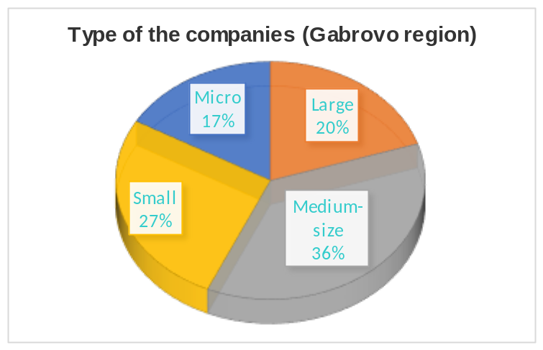

The most active are medium-sized and small companies that need training of their staff. This corresponds to the structure of the companies from this sector in the region.

3.1.2. Training needs
3.1.2.1. Training for technicians
The most preferred training for technicians in Gabrovo region is „„Operating CNC machines““ (22 companies – 73,33%).
The first three top training choices are „Operating CNC machines“ (73,33%), „Operating automated production system“ (43,33%) and „Electrical drives“ (43,33%). The least preferred trainings are „Vacuum and vacuum technology“ and “„Optimal use of compress air“ – 0%.
There are requests for other trainings (3 companies – 10%):
- Production of rope electric hoists and parts for them – 1 company;
- Laser technology – 1 company;
- Galvanic coatings – 1 company.

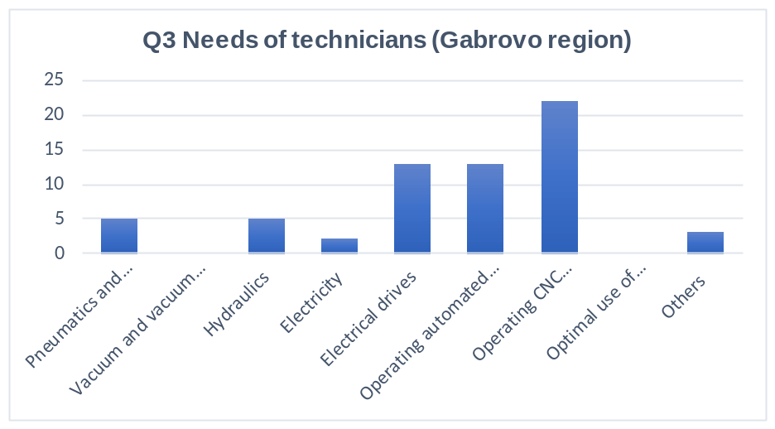

Distribution of preferred training for technicians by types of companies according to employees.
- The most preferred training by micro-enterprises is “„Operating CNC machines“” – 80%.
- The most preferred training by small enterprises is “„Operating CNC machines“” – 62.5%.
- The most preferred training by medium-sized enterprises is “„Electrical engines, complex „Electrical drives““” – 54.54%.
- The most preferred training by large companies is “„Operating CNC machines“” – 83.83%.

      - Training for engineers
The most preferred training for engineers in Gabrovo region is the “Programming and maintenance of CNC machines” – by 83,33% or 25 of the companies.
The first three top training choices are “Programming and maintenance of CNC machines” (83,33%), “Automated manufacturing systems” (43,33%) and “„Electrical engines, complex „Electrical drives““” (36,66%).
The least preferred trainings are “Vacuum engineering and technology” and “Energy efficiency in pneumatic systems” – 0%.

There are two requests for additional training:
- Modern systems and concepts for design of lifting machines – 1 company;
- Laser technology – 1 company.

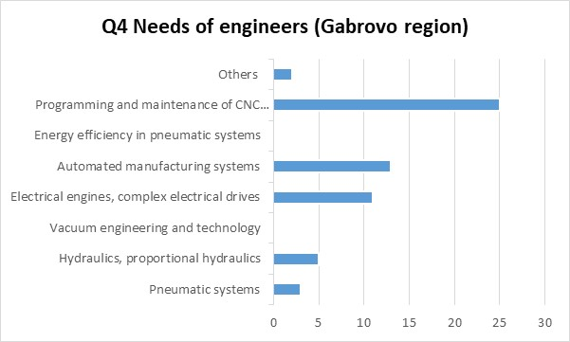

Distribution of preferred training for engineers by type of enterprise according to employees

- The most preferred training by micro-enterprises is “Programming and maintenance of CNC machines” – 80%.
- The most preferred training by small enterprises is “Programming and maintenance of CNC machines – 88.88%.
- The most preferred training by medium-sized enterprises is “Programming and maintenance of CNC machines“ – 81.81%.
- The most preferred trainings by large companies are “Automated manufacturing systems” (83.83%) and “Programming and maintenance of CNC machines“ (83.83%).

      - Soft skills
The top three training choices are „Problem solving“ (66,67%), „Team work“ (53,33%) and „Adaptability and flexibility“ (53,33%).
The least preferred training is „Work ethic“ - 10% or 3 companies selected this training. There are not any requests for other skills training.

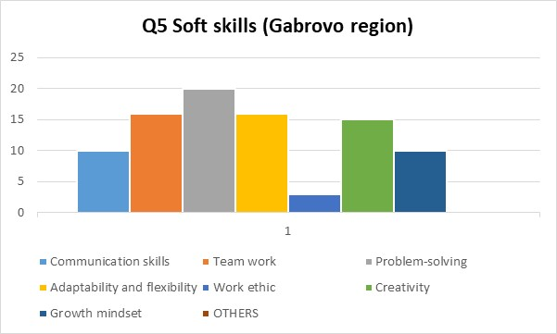

Distribution of soft skills training by type of enterprise according to employees
- The most preferred skills training by micro-enterprises is “Problem-solving” – 80%.
- The most preferred skills training by small enterprises is “Problem-solving” – 62.5%
- The most preferred skills training by medium-sized enterprises is “Adaptability and flexibility” – 63.63%.
- The most preferred skills training by large companies is “Team work” – 83.83%.

      - Preferred teaching methodology
As an average most preferred methodology is “Active blended learning” – 83%.
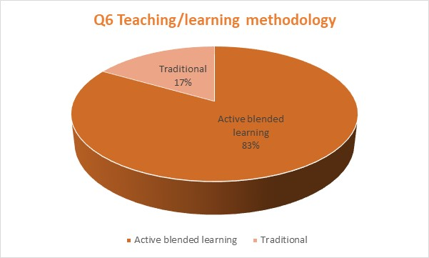

Distribution of preferred teaching methodology by types of companies according to employеes.
The most preferred methodology by all types of enterprises for Gabrovo region is “Active blended learning” with percentages varying from 66.67 % – 100% among different sized companies.

    - Conclusions
The obtained results are directly correlated to the specifics of the production and equipment in the machine-building companies of the region. The programming and work with CNC machines significantly outstrips all other proposed types of training in all types of companies. There is a significant interest in training in key competencies. All surveyed companies have chosen more than one training in this area - most often 2 or 3.

Plovdiv Region (Bulgaria)
    - METRICS
We contacted 150 companies that we estimated would be interested in the survey. Of these, 30 companies completed the survey, which makes 1/5 - 20 percent. Of these 30 companies - 10 are large enterprises – 33%, 15 are medium-sized enterprises – 50% and 5 are small enterprises – 17%, 0 - very small enterprises. The most active are large and medium-sized companies that need training of their staff.

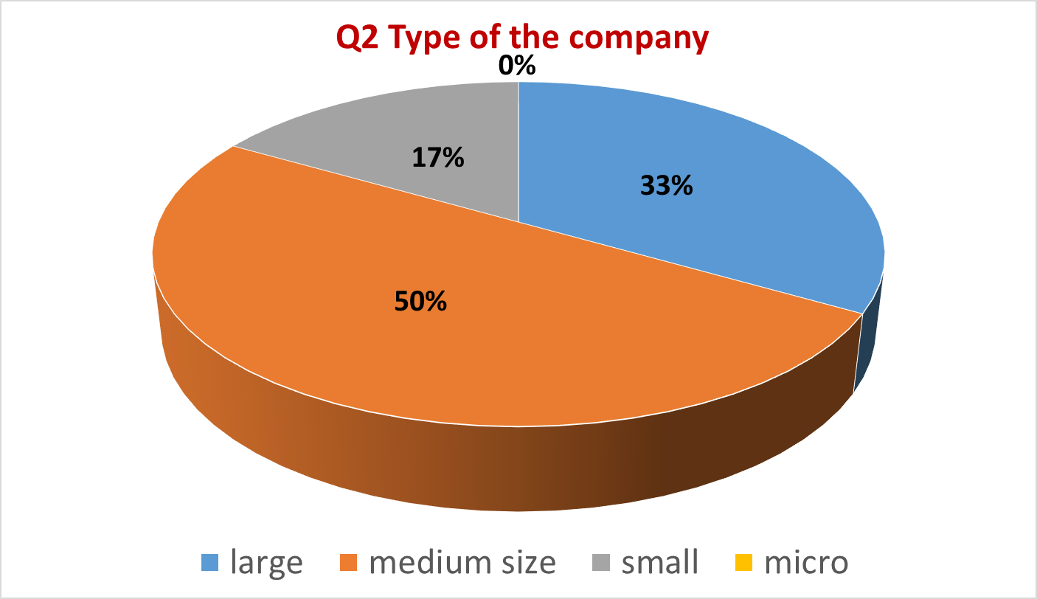

Type of companies according to number of employees

    - Training needs
      - Training for technicians
The most preferred training for technicians is “Electricity” – 16% (20 companies) and “„Operating automated production system“” – 16 % (20 companies).
The first three top training choices are „Electricity“ (16%), „ “Operating automated production system“ “ (16%) and „ “„Pneumatics and electro-pneumatics““ “ (15%).
On the contrary the least preferred training is “„Operating CNC machines“” with only 2% - 3 companies selecting this training.
4 companies have written requests for the following trainings: Electronics, Operators, installers of aircraft structures, Technical drawing - principles, reading drawings, designations in the drawings; Production of special products.

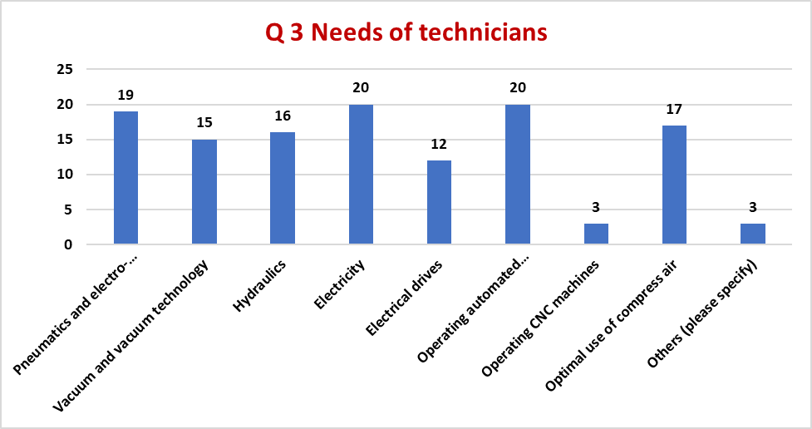

Distribution of preferred trainings for technicians by types of companies according to employees.
- The most preferred training by small enterprises is „„Hydraulics““, „Electricity“ and „„Operating automated production system““ – all three with 60%.
- The most preferred trainings by medium-sized enterprises are „„„Pneumatics and electro-pneumatics“““ and „Electricity“, both with 67%.
- The most preferred training by large companies is „Operating automated production system“ – 80%.
      - Training for engineers
The most preferred training for engineers is the “Automated manufacturing systems” with 21% - 23 of the companies choosing this training.

The first three top training choices are “Automated manufacturing systems” (21%), “Basic schemes in automated pneumatic systems” (19%) and “„Hydraulics“, proportional „Hydraulics“” (18%).

The least preferred training is CNC machines /2%/ - 3 companies chose this training. 3 companies (2%) chose another training indicating Mechanical systems, Fluid mechanics; Welding - principles, types of processes, non-destructive tests; Work / Programming with PLC computers on machines; Operation / maintenance of pneumatic systems with high pressure over 200 bar, Electronics.

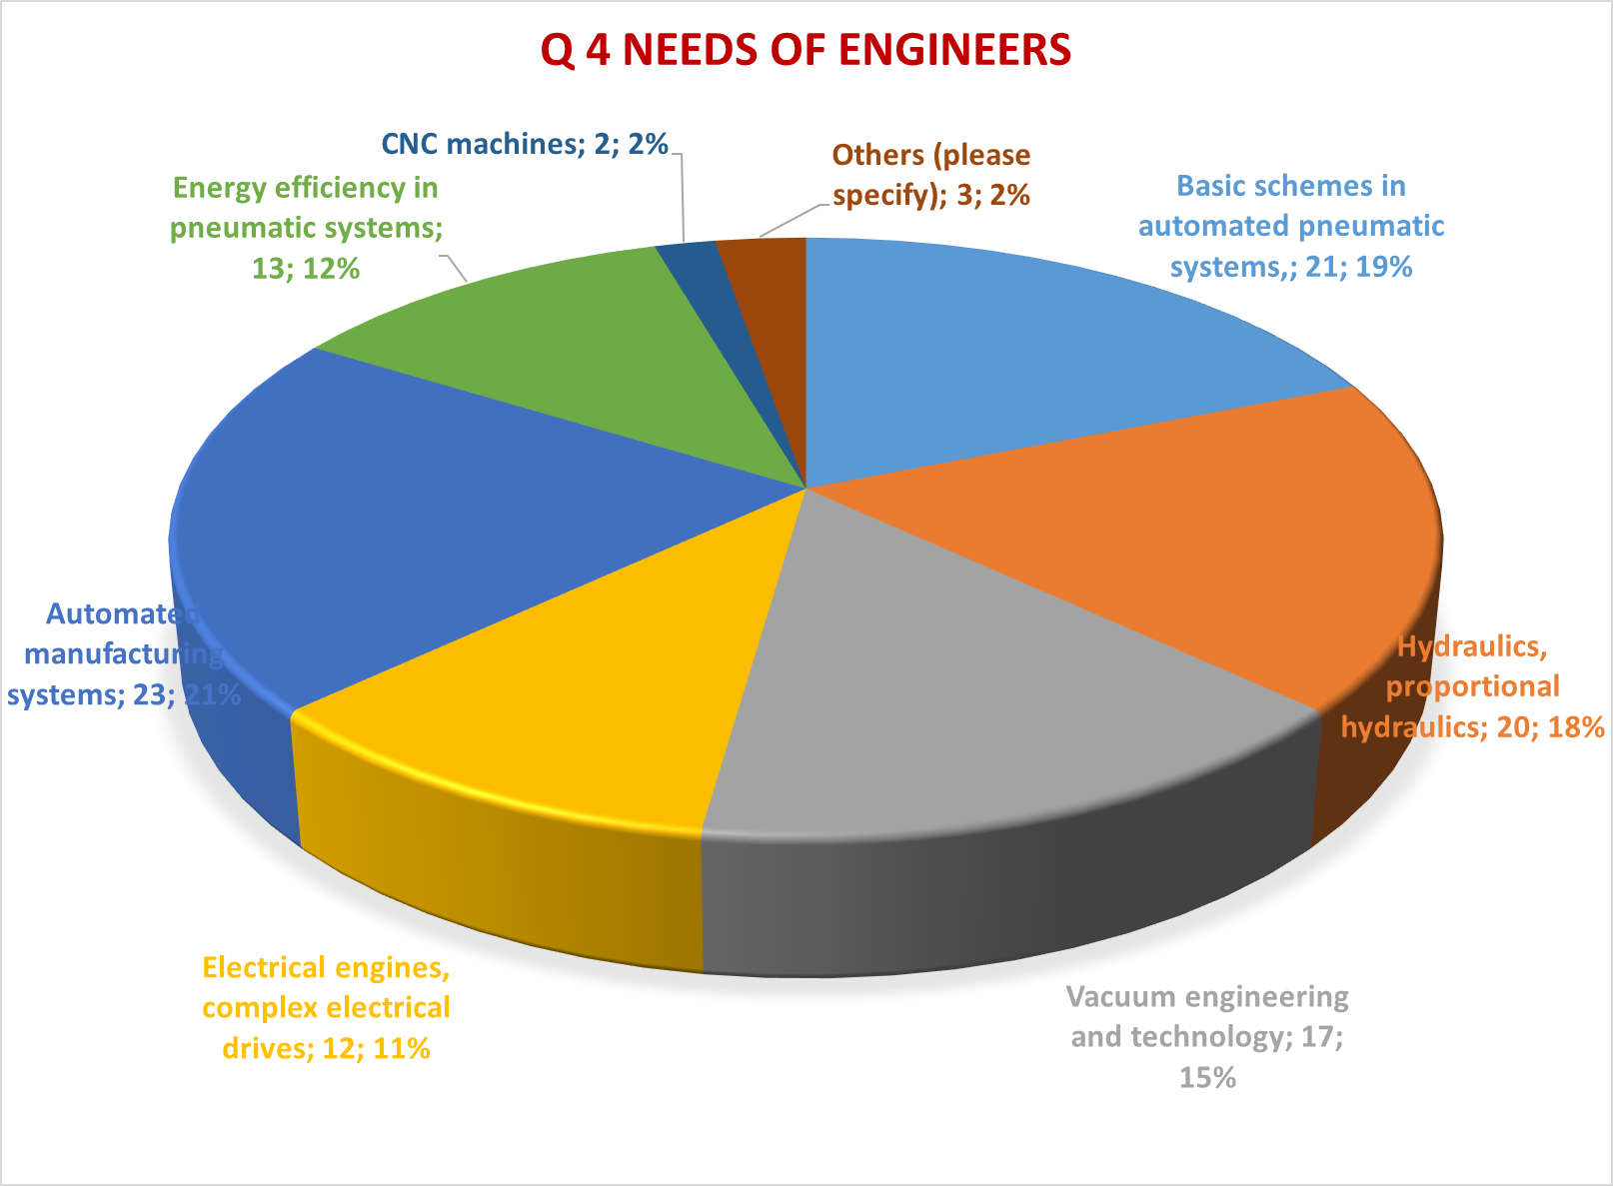

Distribution of preferred training for engineers by type of enterprise according to employees
- The most preferred training by small enterprises is „„Hydraulics“, proportional „Hydraulics““ and „Automated manufacturing systems“ – both with 80 %.
- The most preferred training by medium-sized enterprises is „Basic schemes in automated pneumatic systems“ and „ automated manufacturing systems“ – both with 67%
- The most preferred training by large companies is „Basic schemes in automated pneumatic systems“ and „Automated manufacturing systems“ – both with 90%.

      - Soft skills
- The most preferred training for soft skills is the „Problem Solving“ with 27 of the companies choosing this training – 21%.
- The three top training choices are „Problem solving“ (21%), „Communication skills“ (17%) and „Team work“ (17%).
- The least preferred training is „„Creativity““ - 9% of the companies selecting this training.

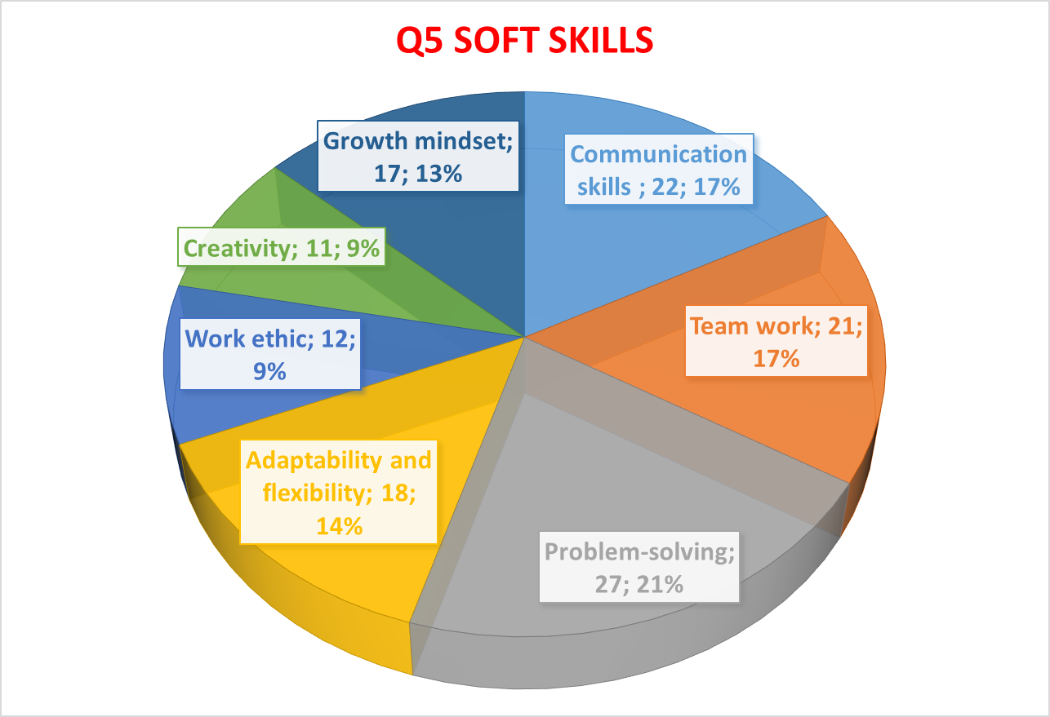

Distribution of soft skills training by type of enterprise according to employees:
- The most preferred skills trainings by small enterprises are „Problem-solving“, „„Work ethic““ and „Growth mindset“ – accounting for 60% of the respondents.
- The most preferred skills training by medium-sized enterprises is „Problem-solving“ – 100%.
- The most preferred skills training by large companies is „Problem-solving“ – 90%.

      - Preferred teaching methodology
80% (24 companies) out of the 30 companies have chosen as preferred teaching methodology the Active blended learning.

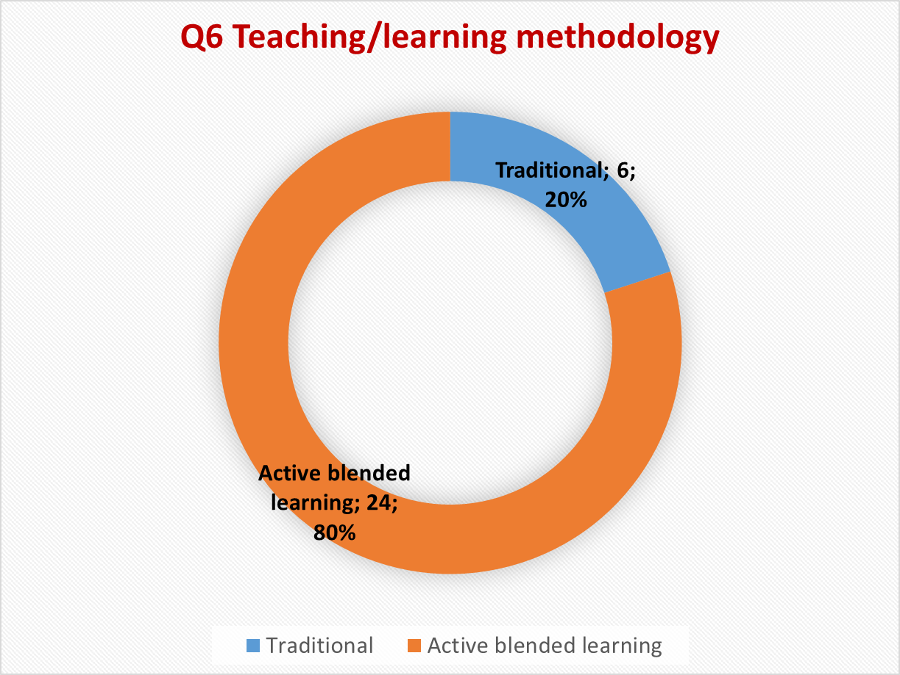

Distribution of preferred teaching methodology by types of companies according to employees.
- The most preferred methodology by small enterprises is Active blended learning – 80%.
- The most preferred methodology by medium-sized enterprises is Active blended learning – 67%.
- The most preferred methodology by large companies is Active blended learning – 100%.

    - Conclusions
We have invited 120 companies to participate in the survey, 30 companies responded - 20 %. Unfortunately, the study was conducted during the COVID-19 pick pandemic times in Bulgaria. Trakia Economic Zone consists mainly of medium and large sized enterprises, which teams have specific specialists who are responsible for staff training. Many of them were ill and were unable to participate in the study, although it was conducted online.
On the other hand, the companies that responded reacted almost immediately. Some of the human resources managers even called to thank us for the extremely useful initiative and project.
The analysis of the survey results showed the following picture of the necessary trainings:
The most preferred training for technicians does not actually indicate big favorites - almost all trainings received similar results, except for the least popular "Operation and adjustment of CNC machines". This shows that the team that prepared the survey itself was well informed about the specific needs of the industry in Bulgaria.
The analysis of the results showed that small companies are equally interested in training on „Hydraulics“, Electricity and „Operating automated production system“, for medium-sizedd companies the most preferred are „„Pneumatics and electro-pneumatics““ and Electricity, and for large - „Operating automated production system“. 20 out of a total of 30 - or 67 percent of the companies have equally chosen trainings on Electricity and „Operating automated production system“ as the most preferred trainings.
According to the data obtained from the analysis of the study, the most preferred training for engineers in small enterprises is „Hydraulics“, proportional „Hydraulics“ and Automated manufacturing systems, by medium-sized enterprises is Basic schemes in automated pneumatic systems and Automated manufacturing systems, by large companies is Basic schemes in automated pneumatic systems and Automated manufacturing systems.
77 percent - 23 companies out of 30, have chosen as the most preferred training for engineers the Automated manufacturing systems. As with technician training, there are no major differences in preferences - almost all are interesting except training CNC machines.

For soft skills training, the small companies prefer the Problem-solving, „Work ethic“ and Growth mindset, the medium-sized and large enterprises prefer the Problem-solving. 27 of the companies, 90%, preferred training for soft skills the Problem Solving.
80 % or 24 of the companies prefer Active blended learning.

These data once again prove how useful for companies in the Trakia Economic Zone - Plovdiv region of Bulgaria, is the creation the educational resources and uploading them an Active Learning Community Platform and its mobile application through the implementation of this project. The team that created the survey on skills deficit of technical and engineering staff in the sector of Machine Building and Mechatronics had previously had extremely accurate observations of employers' needs.

  - EAST MACEDONIA and THRACE (GREECE)
    - METRICS
As part of our effort to approach companies in the field we are interested in, we came in contact with about 500 companies.
The companies that responded are 31, a percentage of about 6%. Of this percentage, 52% are medium-sized enterprises, 22% small enterprises and 26% very small enterprises.
The most active are the medium-sized companies that have a larger turnover, have more employees and show a strong interest in the training of their staff.

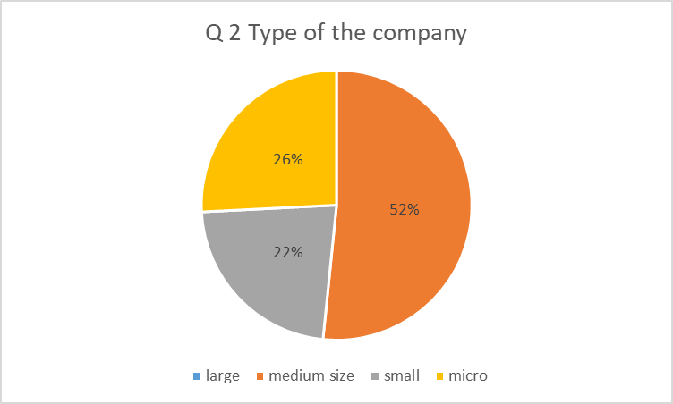
Type of companies according to number of employees

    - Training needs
      - Training for technicians
The most preferred training for technicians is the “„„Pneumatics and electro-pneumatics““” with 48% of the companies choosing this training.
The first three top training choices are “„„Pneumatics and electro-pneumatics““” (48%), “„Operating automated production system“” (45%) and “Electricity” (42%).
On the contrary the least preferred training is “„„Vacuum and vacuum technology““” with only 3% of the companies selecting this training.

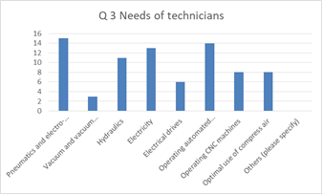
Distribution of preferred trainings for technicians by types of companies according to employеes.

- The most preferred training by micro-enterprises is “„„Pneumatics and electro-pneumatics““” (50%).
- The most preferred training by small enterprises is “„„Pneumatics and electro-pneumatics““” (71%).
- The most preferred training by medium-sized enterprises is “„Operating automated production system“” (75%).
- There are no large companies in the sample.

      - Training for engineers
The most preferred training for engineers is the “Automated manufacturing systems” with 52% of the companies choosing this training.
The top three training choices are “Automated manufacturing systems” (52%), “Basic schemes in automated pneumatic systems” (42%) and “Energy efficiency in pneumatic systems” (39%).
On the contrary the least preferred training is “CNC machines” since no company chose this training.
Two companies (6%) have chosen “Automations” as their preferred training.

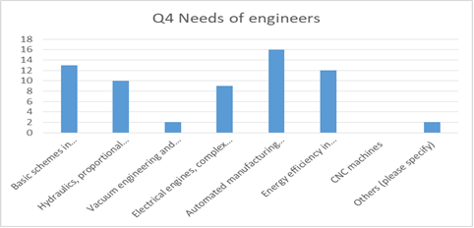
Distribution of preferred training for engineers by type of enterprise according to employees
- The most preferred trainings by micro-enterprises are “Automated manufacturing systems” and “Energy efficiency in pneumatic systems“ with 25% each.
- The most preferred training by small enterprises is “Basic schemes in automated pneumatic systems” (71%).
- The most preferred training by medium-sized enterprises is “Automated manufacturing systems” (81%).
- There are no large companies in the sample.

      - Soft skills
The most preferred training for soft skills is the “Problem Solving” with 77% of the companies choosing this training.
The first three top training choices are “Problem solving” (77%), “Adaptability and flexibility” (71%) and “Team Work” (58%).
On the contrary the least preferred training is “Growth mindset” with 29% of the companies selecting this training.

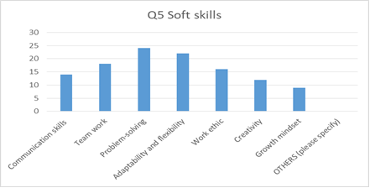

Distribution of soft skills training by type of enterprise according to employees
- The most preferred skills training by micro-enterprises is “„Creativity“” (63%).
- The most preferred skills training by small enterprises is “Problem-solving” (86%).
- The most preferred skills training by medium-sized enterprises is “Problem-solving” (88%).
- There are no large companies in the sample.

      - Preferred teaching methodology
65% out of the 31 companies have chosen as preferred teaching methodology the Active blended learning.

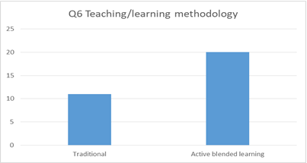

Distribution of preferred teaching methodology by types of companies according to employеes.
- The most preferred methodology by micro-enterprises is Active blended learning (63%).
- The most preferred methodology by small enterprises is Active blended learning (57%).
- The most preferred t methodology by medium-sized enterprises Active blended learning (69%).
- There are no large companies in the sample.

    - Conclusions
Despite the fact that a relatively big number of companies (500 companies) have been asked to fill in the questionnaire of the program only 6% of them (31) completed it. The majority of them are medium sized companies (52%).
Given the data which derived from the analysis of the questionnaires the most preferred training for technicians is the “„„Pneumatics and electro-pneumatics““” in all micro and small companies, while in the medium sized companies it is “Operating automated system”.
The preferred training for engineers in micro and medium size companies is the Automated manufacturing systems, with micro companies preferring additionally the Energy efficiency in pneumatic systems training. The small companies prefer the Basic schemes in automated pneumatic systems.
As for the soft skills training the micro companies prefer the “„Creativity“” training and the small and medium sized companies prefer the “Problem Solving” training.
The vast majority of the companies (65% of them) prefer the Active blended learning.

POMORSKIE REGION (POLAND)
    - METRICS
We have contacted 150 companies that we estimated would be interested in the survey. The survey was completed by 39 companies from Pomorskie region (26,7 %)
Structure of respondents according to the number of employees, micro (9 - 22,5 %), small (12 - 30%), medium size (15 - 37,5 %), large companies (4 - 10%).
Most active companies that need training of their staff, were form the small and medium size group.

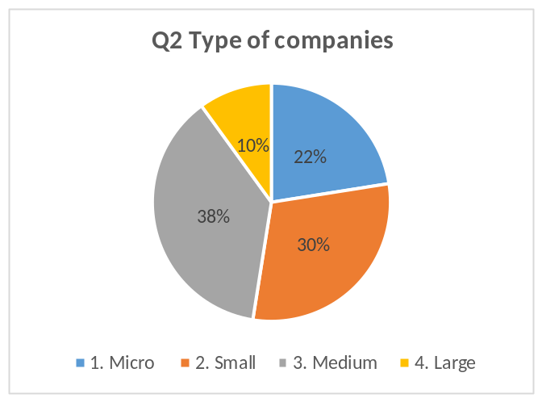

Type of companies according to number of employees

    - Training needs
      - Training for technicians
Most preferred training for technicians is “„Operating automated production systems” (19 companies).
The top 3 most preferred trainings are “„Operating automated production system“”, “„Operating CNC machines“”, “Electricity / Electrical drivers”.
“„„Vacuum and vacuum technology““” has the lowest percentage.
8 companies proposed another training: Industry automation, Technical research and analysis, Construction of agricultural and municipal machinery Building structures, Construction for the shipbuilding and offshore industry, Support for programs such as solid edge constructions, Technical evaluations, Control systems, Automation, The principle of operation of machine.

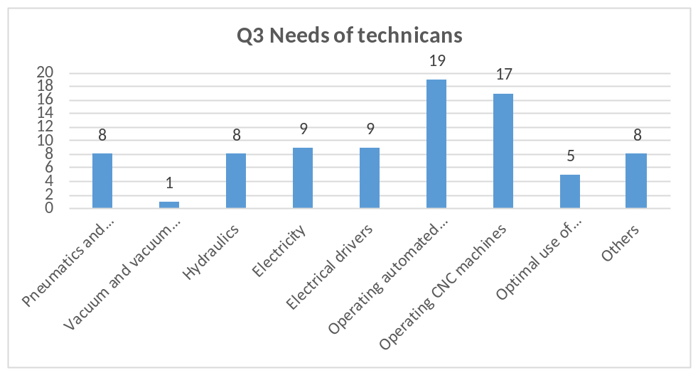

Distribution of preferred trainings for technicians by types of companies according to employеes.
The most preferred training by micro-enterprises: „Operating CNC machines“.
The most preferred training by small enterprises: „Operating automated production system“.
The most preferred training by medium-sized enterprises: „Operating automated production system“.
The most preferred training by large companies: „Operating CNC machines“.

      - Training for engineers
Most preferred training for engineers: „Automated manufacturing systems - diagnostics, maintenance, troubleshooting“
The first 3 most preferred trainings: „Automated manufacturing systems - diagnostics, maintenance, troubleshooting“; „Basic schemes in automated pneumatic systems, design of pneumatic and electrical pneumatic systems, diagnostics, maintenance, optimization“; „Electrical engines, complex „Electrical drives““
The lowest percentage has: „Vacuum engineering and technology, vacuum systems, various capture methods in vacuum engineering“
There are requests for other trainings: Production technology planning; tooling in unit production; calculation of execution time; machine design, precision mechanics programming of PLC and HMI controllers; machine safety; Support for programs and drivers
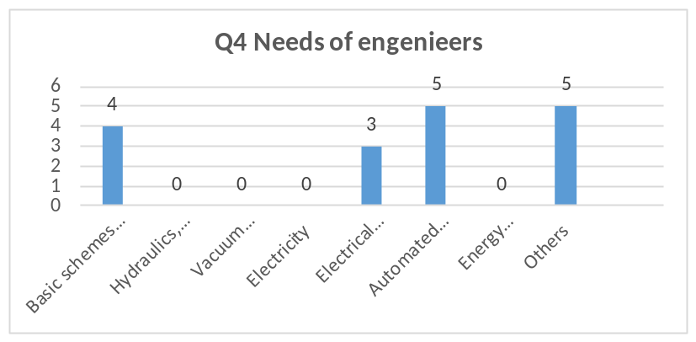

Distribution of preferred training for engineers by type of enterprise according to employees
The most preferred training by micro-enterprises: „Automated manufacturing systems - diagnostics, maintenance, troubleshooting“
The most preferred training by small enterprises: „Automated manufacturing systems - diagnostics, maintenance, troubleshooting“
The most preferred training by medium-sized enterprises: „Automated manufacturing systems - diagnostics, maintenance, troubleshooting“
The most preferred trainings by large companies: „Basic schemes in automated pneumatic systems, design of pneumatic and electrical pneumatic systems, diagnostics, maintenance, optimization“.

      - Soft skills
The top 3 most preferred skills trainings: Communication skills (ability to communicate and build trust, effective receiving and sending of information); Teamwork (active listening and understanding different viewpoints, ability to respect and trust others, self-evaluation and self-criticism, endurance when working under pressure); „Problem-solving (analytical and critical thinking; taking personal responsibility, identifying problems, decision making and response, risk assessment)“.
The lowest percentages has „Work ethic“.
There are requests for other skills trainings: Stress resistance building responsibility for your actions.

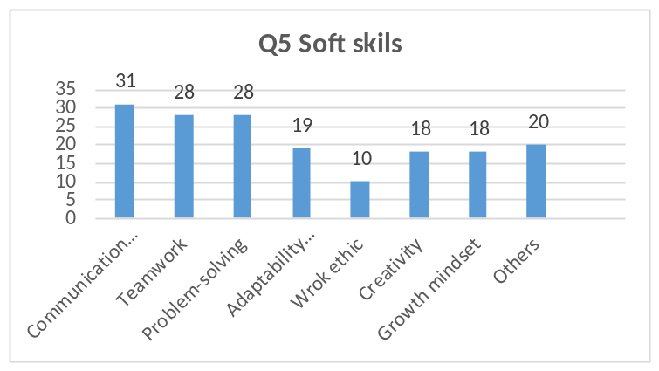

Distribution of soft skills training by type of enterprise according to employees
The most preferred skills training by micro-enterprises is „Communication skills – (ability to communicate and build trust, effective receiving and sending of information)“.
The most preferred skills training by small enterprises is „Communication skills – (ability to communicate and build trust, effective receiving and sending of information)“.
The most preferred skills training by medium-sized enterprises is „Communication skills – (ability to communicate and build trust, effective receiving and sending of information)“.
The most preferred skills training by large companies is „Problem-solving (analytical and critical thinking; taking personal responsibility, identifying problems, decision making and response, risk assessment)“.

      - Preferred teaching methodology
Active blended learning – the students get familiar with the learning content by using PP presentations online or through their smart phones, then they discuss the topics with the teacher in the classroom so as to clarify difficult issues and solve problems, after that they do their lab work – 24 answers.
Traditional – the teacher delivers the learning content in the classroom and then the students do their lab work – 16 answers.

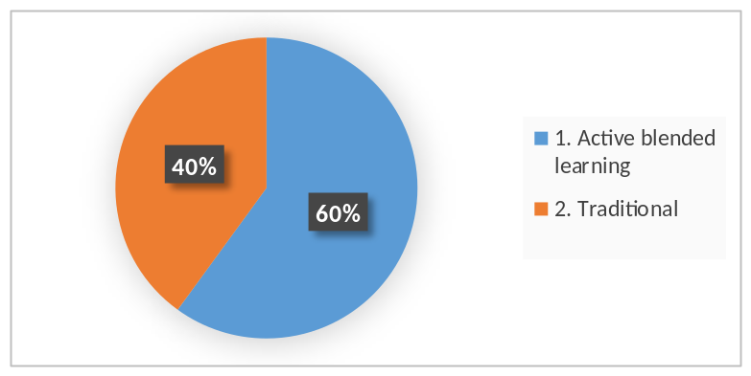
Distribution of preferred teaching methodology by types of companies according to employеes.
The most preferred methodology by micro-enterprises: Active.
The most preferred methodology by small enterprises: Both active and traditional.
The most preferred t methodology by medium-sized enterprises: Active.
The most preferred methodology by large companies: Active.

    - Conclusions
150 companies have participated in the survey, 40 companies responded (26,7 %). Unfortunately, the study was conducted in COVID-19 pandemic, when most companies struggled with problems. Pomorskie Region consists mainly of micro, small and medium enterprises. Many of them were hard to reach and were unable to participate in the study, although it was conducted online.
The analysis of the survey results showed the following picture of the necessary trainings:
The most preferred training for all companies was „Operating automated production system“. The second and third trainings were: „Operating CNC machines“, Electricity / Electrical drivers.
The analysis of the results showed that micro and small companies are mostly interested in trainings „Operating automated production system“ and „Operating CNC machines“.
According to the data obtained from the analysis of the study, the most preferred training for engineers for micro, small and medium enterprises is „Automated manufacturing systems - diagnostics, maintenance, troubleshooting“. Large companies preferred trainings in „Basic schemes in automated pneumatic systems, design of pneumatic and electrical pneumatic systems, diagnostics, maintenance, optimization“. We had received few responses regarding the needs of engineers.
For soft skills training, the small and medium companies prefer the „Communication skills – (ability to communicate and build trust, effective receiving and sending of information)“, and large enterprises prefer „Problem-solving (analytical and critical thinking; taking personal responsibility, identifying problems, decision making and response, risk assessment)“. 60% (24) of the companies prefer Active blended learning.

Niš Region (Serbia)
    - METRICS
In Niš Region, 30 companies completed survey - 47% are micro companies, 27% small ones, 23 medium-sized and 3% were large companies.

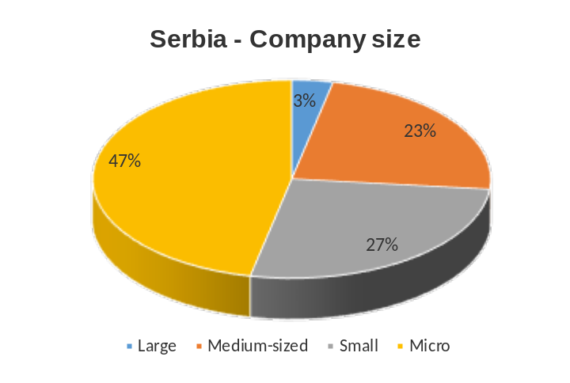

    - Training needs
      - Training for technicians
Most preferred training for technicians is „Operating CNC machines“ – 40% of companies expressed their interests in this type of training.
Top 3 most preferred trainings are: „Operating CNC machines“ – 40%, „„Pneumatics and electro-pneumatics““ – 34% and „Operating automated production system“ – 7%.
Lowest percentage were noted for „„Vacuum and vacuum technology““ and „Optimal use of compress air“ – 0%.
Other requested trainings were noted in the field of welding and Optimization of technical processes.

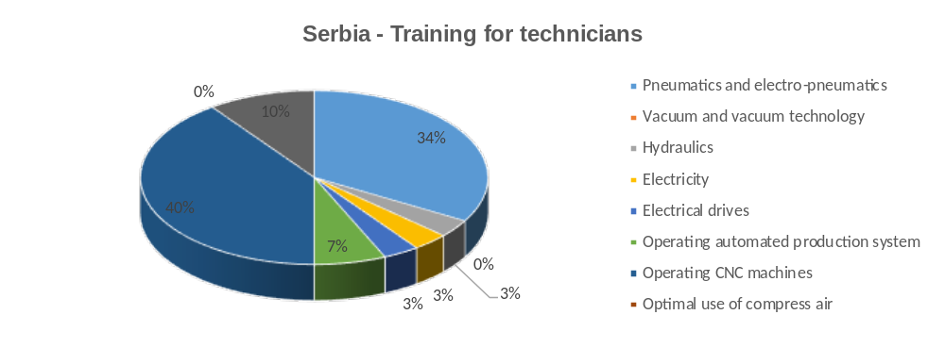
Distribution of preferred trainings for technicians by types of companies according to employеes.
The most preferred training by micro-enterprises was „Operating CNC machines“ – 43%.
The most preferred training by small enterprises was „„Pneumatics and electro-pneumatics““ – 38%.
The most preferred trainings by medium-sized enterprises were „„Pneumatics and electro-pneumatics““ and „Operating CNC machines“, both with 43%.
The most preferred training by large companies was „Operating CNC machines“ – 100%.

      - Training for engineers
Most preferred trainings for engineers are „Hydraulics“, proportional „Hydraulics“ – 23% and Automated manufacturing systems – 23%.
Top 3 preferred trainings are: „Hydraulics“, proportional „Hydraulics“ 23%, Automated manufacturing systems 23%, and Basic schemes in automated pneumatic systems, 20%.
Lowest percentage were noted for Vacuum engineering and Energy efficiency in pneumatic systems – 3% in both.
Other requested trainings were noted in the field of Development of electronic boards, Design and construction of welded construction and Machine maintenance and repairing, Quality assurance, quality control and testing.
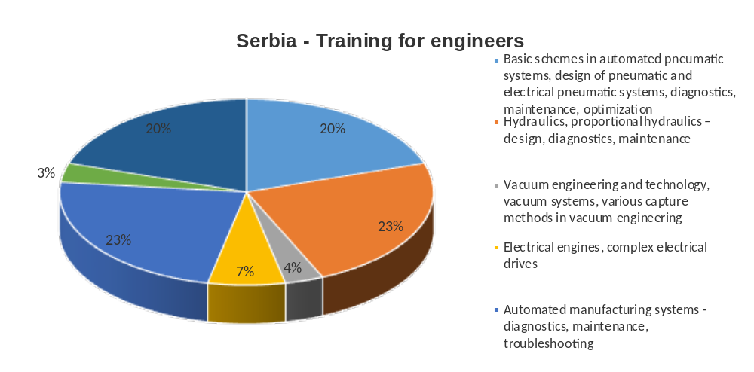
Distribution of preferred training for engineers by type of enterprise according to employees
The most preferred training by micro-enterprises is „Hydraulics“, proportional „Hydraulics“ – 21%.
The most preferred training by small enterprises is Automated manufacturing systems – 50%.
The most preferred training by medium-sized enterprises is „Hydraulics“, proportional „Hydraulics“ – 43%.
The most preferred training by large companies is Automated manufacturing systems – 100%.

      - Soft skills
Most preferred skills trainings are: Communication skills – 44%, Problem solving – 30% and Adaptability and flexibility – 14%.
Lowest scores were given to Team work, „Work ethics”, „Creativity“ and Growth mindset – 3%.
There were no requests for additional trainings for soft skills.
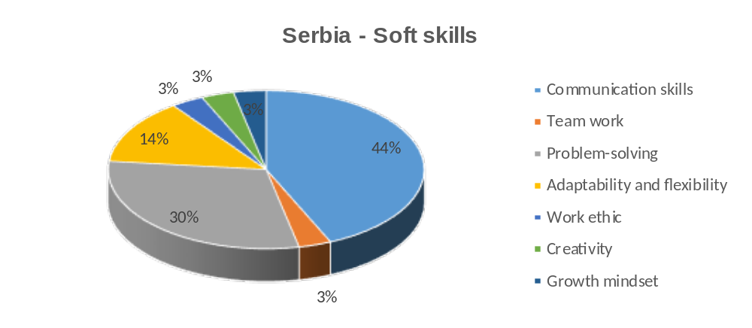
Distribution of soft skills training by type of enterprise according to employees
The most preferred skills training by micro-enterprises is Communication skills – 29%.
The most preferred skills training by small enterprises is Communication skills – 38%.
The most preferred skills training by medium-sized enterprises is Communication skills – 71%.
The most preferred skills training by large companies is Communication skills – 100%.

      - Preferred teaching methodology
Preferred teaching methodology among Serbian companies is Active blended learning with 83%.
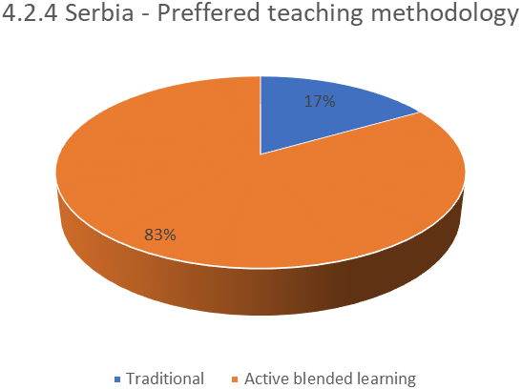

Distribution of preferred teaching methodology by types of companies according to employеes.
The most preferred methodology by micro-enterprises was Active blended learning – 86%
The most preferred methodology by small enterprises was Active blended learning – 75%
The most preferred methodology by medium-sized enterprises was Active blended learning – 86%
The most preferred methodology by large companies was Active blended learning – 100%

    - Conclusions
The most desirable trainings for technicians is “Operating CNC” machines and “Pneumatics and electro-pneumatic”.
The most desirable trainings for engineers are „Hydraulics“, proportional „Hydraulics“ and Automated manufacturing systems.
The most preferred skills training is Communication skills.
The most preferred methodology is Active blended learning.

CROSS-REGION ANALYSIS

Partnership regions covered
The study of the needs for professional training of technicians and engineers in mechanical engineering and mechatronics was conducted in two regions of Bulgaria - Gabrovo and Plovdiv, East Macedonia and Thrace, Greece, Pomorskie Region, Poland and Nis region, Serbia.
These regions are very different, both in area and population and the most developed sectors of the economy.
The smallest regions, both in area and population, are those in Bulgaria. At the same time, they are some of the best developed economic regions in Bulgaria with a predominant industrial sector, including many companies in the field of mechanical engineering and mechatronics. For Gabrovo Region the processing industry has a major share in the overall economy of the region and constitutes about 60% of the total production, twice the average at a country level. Manufacturing of machinery, equipment and fabricated metal products has a leading role in the processing industry. Almost half of the income generated by the industry in the region comes from the above mentioned manufacturing.
Plovdiv Region is the number 1 industrial center in Bulgaria. The total production is about BGN 17.5 billion in 2018 and almost BGN 9.5 billion of it is from the industrial sector. The structure of the local economy is strongly dominated by manufacturing, which, according to NSI data, occupies 39.9% of it (relative to value added), which is more by 12% than the second largest sector. In relation to the produced production the share of the production is 55 %, and in relation to the incomes from the activity it is 36.3 %. Trakia Economic Zone / TEZ / - the largest and most sustainable industrial zone not only in Bulgaria but also in Southeast Europe, is located in Plovdiv region.
The region of East Macedonia and Thrace, Greece comprises about 5.6% of the country's population and is mainly an agricultural area. The manufacturing sector is dominated by medium to low technology sectors, such as the food industry, textiles and clothing, mining and quarrying, manufacture of pulp, paper and paperboard and manufacture of tobacco products. The Municipality of Kavala plays the role of the gateway to the trans-European axes for the Aegean Sea and the center of international trade routes for the Balkans.
Pomorskie Region (Pomeranian region), Poland is one of the most dynamically developing regions in Poland. Many key companies playing significant part in the national economy are located in the region, contributing to its high social and economic potential. The basis of the region's economy consists in the services sector which is one of the most innovative ones in Poland. In 2017, three sectors registered high shares of regional GAV: (1) services - trade, repair of motor vehicles and motorcycles, transport and storage, accommodation and food service activities, information and communication (NACE G, H, I, J) (29.7%), industry (26.5%), and other services (24.9%). Foreign firms make up 12.5% of all companies in the region.
Nis Region, Serbia. The territory covered by the CCIS - Regional Chamber of Commerce of the Nisava, Pirot and Toplica administrative districts with its headquarters in Nis, is included in the analysis. This territory covers an area of 8.74 percent of the total territory of the Republic of Serbia.
In the structure of GDP of the RCC Nis, the most represented services are 46.5%, industry 40.3%, which is above the national average and agriculture, which participates with 8.1. Construction participates with 5.1%.
Sector of industry within CCIS RCC Nis consists of six branches: metal and electrical industry, construction industry, chemical, rubber and non-metal industry, textile, clothing, leather and footwear industry, energy and mining and pharmacy and medical activity. Export-oriented region.
In all regions, significant attention is paid to innovation. Universities play a major role almost everywhere.
Pomeranian region (Poland) is a potent R+D activity centre which is reflected in high positions it occupies in such categories as R+D expenses, or number of employees in R+D sector. Such a situation is favoured by the fact that the region is one of the largest academic centres in Poland, where relatively high number of graduates come from technical and science specialties. In comparison with other regions, Pomeranian voivodship is on 4th place as far as the regions' innovation potential is concerned.
The East Macedonia and Thrace Region is characterized by a gradual building of capacities in the fields of research, technology development and innovation (RTDI) by increasing the presence of academic institutions, i.e., Democritus University of Thrace and International University. The research efforts in the region are concentrated mainly in the academic sector. However, the limited absorptive capacity and demand by firms for RTDI services and the absence of infrastructures for enhancing technology transfer limit the potential for spill-over effects and the creation of long term linkages between regional firms and the higher education institutions (HEI) sector in the region.
Technology Park in Niš, opened in 2020, is located in the Region of Nis. The Park represents not only the largest, but the key capital investment in the City, as well as in the Region of South and Eastern Serbia. The vision of the Scientific and Technology Park Nis (STP) is to become a regional center for the dynamic development of innovative science and technology entrepreneurship, and the basis of reengineering the economy of not only the region of South and East Serbia, but the strengthening of the global competitiveness of the entire Republic of Serbia.
In Plovdiv Region the team of "Trakia Economic Zone" in 2020 laid the foundations of the Consortium "Carbon Neutral Industrial Parks" for the development of industrial zones in Bulgaria in four districts - Plovdiv, Burgas, Gabrovo and Haskovo. The strategic project, which is in line with the EU Green Deal, aims to create an attractive investment and innovation environment in the areas of the participating municipalities, reduce carbon emissions and improve working conditions and living standards.
The Technical University of Gabrovo is located in Gabrovo, where a Competence Center "Intelligent Mechatronic, Eco- and Energy Saving Systems and Technologies" is established. Together with the Regional Innovation Center they must lead to the successful commercialization of the obtained scientific results in a priority area for the Bulgarian economy "Mechatronics and clean technologies".

4.2. Share of engineers and technicians from total number of employees in the region
There is no official statistics for any of the regions on the share of technicians and engineers in the total number of employees. Based on rough estimates, it can be said that in all regions there is a sufficient number of potential users of the project results. The total number of technicians and engineers is about 52,000 employees.

Opportunities for professional training of technicians and engineers
There are good opportunities for acquiring an engineering qualification in all analyzed regions. There is a university / branch of a university that offers training to engineering specialists in the field of mechanical engineering and / or mechatronics in each region.
The same applies to the training of technical staff (excluding Greece)

Opportunities for validation of non-formal learning
The rapid development of technology requires the constant maintenance and improvement of skills among engineers and technicians in mechanical engineering and mechatronics. Very often it is based on informal learning and non-formal education. The process of validation of this knowledge for technical staff (at the level of secondary education or 3 - 4 level of the European Qualifications Framework) differs from country to country. For example, in Poland the so-called “market qualifications” certificate is issued. Only in Greece, there is currently no comprehensive national framework for validation of non-formal education and informal learning.
No procedures are established for validation of knowledge of engineering personnel

Training needs
In connection with the study of the needs for vocational training, contacts have been made with 1002 companies from the five regions in the sector of mechanical engineering and mechatronics. 161 companies or 16.07% of all companies responded. The relatively low response rate can be explained with the survey period - November and December 2020 - the strongest second wave of the COVID-19 in Europe.
The greatest percentage of respondents are among medium-sized enterprises - 64 (39.75%). This is broadly consistent with the structure of enterprises in this sector. The small enterprises follow - 40 (24.84%) and micro enterprises - 36 (22.36%). The share of large enterprises 21 (13.04%) with the largest number of technicians and engineers is also significant. Their percentage is much higher than their share of the total number of enterprises.
Most of the large enterprises that have responded are from Plovdiv (Bulgaria) region, followed by Gabrovo (Bulgaria) - 6 (20%). No large companies from Greece responded.
This structure of the respondents fully corresponds to the economic profiles of the regions. A significant number of large enterprises from this sector are concentrated in the Thrace Economic Zone in the region of Plovdiv (Bulgaria), while the Kavala (Greece) region is characterized by micro and small enterprises.
The above distribution shows that there is a need for professional qualification of technicians and engineers in all types of enterprises.

    - Training needs of technicians
When studying the needs of technicians in different regions, we have obtained different results.
The most preferred training in Gabrovo Region /Bulgaria/ is "Operating CNC machines" (22 companies - 73.33%), which has been selected by all types of companies. The result is not a surprise, given that this is the most common equipment in machine building companies and the shortage of staff is significant. For Plovdiv Region /Bulgaria/ the most preferred trainings for technicians are “Electricity” - (20 companies, or 16%) and “Operating automated production system” - (20 companies, or 16%). For East Macedonia and Thrace Region /Greece/ the most preferred training is the “Pneumatics and electro-pneumatics“ - 48% of the companies have selected this training. The most preferred training for technicians in Pomeranian region is "Operating automated production system" (19 companies) and in Nis Region /Serbia/ - "Operating CNC machines" - 40% of companies expressed their interests in this type of training
The summarized information shows that there is no training option, which has not been selected at least by one company.
The top three most preferred trainings for all regions are:
- Operating CNC machines – 62 (17,46%);
- Operating automated production systems – 58 (16,34%);
- Pneumatics and electro-pneumatics – 57 (16,05%).
On average, the companies have selected 2.2 types of training.

According to the type of companies, their preferences are distributed as follows:
- Micro enterprises:
Operating CNC machines is the most preferred in 3 of the 5 regions – Gabrovo /Bulgaria/, Pomeranian Region /Poland/ and Nis /Serbia/. In Greece the most preferred is Pneumatics and electro-pneumatics.

- Small companies:
Pneumatics and electro-pneumatics – Greece and Serbia,
Operating CNC machine“ – Gabrovo /Bulgaria/,
Electricity and Hydraulics“– Plovdiv /Bulgaria/;
Operating automated production systems - Poland.

- Medium-sized companies:
Pneumatics and electro-pneumatics is the most preferred training in two regions – Serbia and Plovdiv /Bulgaria/;
Operating automated production systems – in 2 regions – Poland and Greece;
Electrical engines, complex Electrical drives - in Gabrovo /Bulgaria/;
Operating CNC machines – in Nis /Serbia/
Electricity – in Plovdiv /Bulgaria/

- Large companies:
Operating CNC machines – Gabrovo /Bulgaria/, Poland and Nis /Serbia/
Operating automated production systems – Plovdiv /Bulgaria/.

In 4 of the 5 regions there are requests for additional trainings. Some of them are closely related to:
- The products, manufactured by the respective company (Production of rope electric hoists and parts for them, Construction of agricultural and municipal machinery, Construction for the shipbuilding and offshore industry, installers of aircraft structures);
- Specific processes in mechanical engineering (galvanic coatings, laser technologies, welding),
- General issues of mechanical engineering and electrical engineering / electronics - Technical evaluations, Control systems, Automation, The principle of operation of machine, Electronics, Optimization of technical processes.
- Basic knowledge of mechanical engineering - Technical drawing - principles, reading drawings, designations in the drawings.
The most worrying are the requests related to training for the basic knowledge of technicians - technical drawing, reading drawings, recognition, etc., which suggests that this is not mastered in school or those appointed to these positions have no technical education (most probably).

    - Training needs of engineers
When studying the needs of engineers in different regions, we have obtained relatively similar results.
The most preferred training for engineers:
- in Gabrovo region is Programming and maintenance of CNC machines with 83,33% - 25 of the companies chose this training ;
- in Plovdiv region is Automated manufacturing systems with 21% - 23 of the companies choosing this training;
- in Greece is Automated manufacturing systems with 52% of the companies choosing this training;
- in Poland is Automated manufacturing systems - diagnostics, maintenance, troubleshooting.
- In Nis are Hydraulics, proportional Hydraulics and Automated manufacturing systems – 23%.
The summarized information shows that there is no training option, which has not been chosen at least by one company.

The top three most preferred trainings for all regions are:
- Automated manufacturing systems – 64 (24,24%);
- Basic schemes in automated pneumatic systems, design of pneumatic and electrical pneumatic systems, diagnostics, maintenance, optimization 47 (17,80%);
- Hydraulics, proportional Hydraulics – 42 (15,91%).
The least chosen training is: Vacuum engineering and technology, vacuum systems, various capture methods in vacuum engineering – 20 (7,58).

On average, the companies have selected 1.64 types of training.
According to the type of companies, their preferences are distributed as follows:
- Micro enterprises:
- Automated manufacturing systems – diagnostics, maintenance, troubleshooting - in Greece (25%) and in Poland.
- Programming and maintenance of CNC machines – 80% in Gabrovo.
- Energy efficiency in pneumatic systems with 25% in Greece
- Hydraulics“, proportional Hydraulics - in Nis (21%).

- Small companies:
- Automated manufacturing systems – diagnostics, maintenance, troubleshooting - in Plovdiv (80 %), Nis 50% and in Poland.
- Programming and maintenance of CNC machines – 88.88% in Gabrovo;
- Hydraulics, proportional Hydraulics“ - in Plovdiv (80%)
- Basic schemes in automated pneumatic systems in Greece (71%)

- Middle-sized companies:
- Automated manufacturing systems – diagnostics, maintenance, troubleshooting – in Plovdiv (67%), Greece (81%) and Poland
- Programming and maintenance of CNC machines – 81.81% in Gabrovo
- Basic schemes in automated pneumatic systems – 67% in Plovdiv
- Hydraulics, proportional Hydraulics – 43% in Nis.

- Large companies:
- Automated manufacturing systems – diagnostics, maintenance, troubleshooting – 100% in Nis, 83.83% in Gabrovo and 90% in Plovdiv.
- Programming and maintenance of CNC machines - 83.83% in Gabrovo.
- Basic schemes in automated pneumatic systems – 90% In Plovdiv and Poland.

Regardless of the type of enterprises (excluding Gabrovo), 3 types of training are preferred in different order. The choice of companies from Gabrovo is related to the specifics of production in the region.
There is a request for other training topics in three of the regions:
- Gabrovo: Modern systems and concepts for design of lifting machines from 1 company and Laser technology – from 1 company.
- Greece: Automations – 2 companies.
- Poland: Production technology planning; Tooling in unit production; Calculation of execution time; Machine design, Precision mechanics programming of PLC and HMI controllers; Machine safety; Support for programs and drivers
- Serbia: Development of electronic boards; Design and construction of welded construction; Machine maintenance and repairing, Quality assurance, quality control and testing.
Most of the additionally proposed topics are from Poland, which is directly related to the fact that in Poland 4 of the proposed topics are not selected by any company, as well as the small number of training preferences for the rest of the proposed trainings (a total of 17 out of 41 surveyed companies).

Training needs related to soft skills
All soft skills are selected by the companies. It is noteworthy that most of the companies have chosen at least 2 skills, and most of them even more soft skills to train their staff. The exception is Serbia, where companies have chosen only one skill. At the other pole is Poland with 176 or an average of 4.3 skills per company, followed by Plovdiv - 124 or 4.13 skills per company, Greece - 114 or 3.8 skillsper company and Gabrovo - with 3 skills per the company

The most preferred skill in Greece (77%), Gabrovo (66,67%) and Plovdiv (21%) is Problem solving. In Poland and Serbia the most preferred skill is Communication skills.
Problem solving dominates as the first choice of small and medium-sized companies in Bulgaria (Gabrovo and Plovdiv), Greece and large companies in Bulgaria (Plovdiv) and Poland.
Communication skills is the first choice of micro, small and medium-sized companies in Poland and all types of companies in Nis.
Work ethic is the least preferred training in Bulgaria (Gabrovo) - (10%), Poland and Serbia; Creativity - in Bulgaria (Plovdiv) – (9%) and Growth mindset – in Greece (29%).
There are requests for other skills trainings in Poland: Stress resistance and Building responsibility for your actions.

Training methodology
The companies had the option to choose between 2 training methods:
- Active blended learning – the learners get familiar with the learning content by using PP presentations online or through their smart phones, then they discuss the topics with the teacher in the classroom so as to clarify difficult issues and solve problems, after that they do their lab work;
- Traditional – the teacher delivers the learning content in the classroom and then the learners do their lab work.
In all regions, all types of companies have predominantly supported Active blended learning, with percentages ranging between 65% (Greece) and 83% in Gabrovo-Bulgaria and Nis-Serbia. Support among all types of companies is between 57% and 100%, with the lowest percentage among small companies (57%) in Greece.

CONCLUSIONS
The analysis of the socio-economic characteristics of the regions where the project is implemented shows that there are many differences between them:
There is a different degree of industry development and more specifically of mechanical engineering and mechatronics in the different regions. The least developed in this respect is East Macedonia and Thrace (Greece), while these industries occupy the greatest share of economy in the regions of Gabrovo and Plovdiv (Bulgaria). There are also well-developed production sectors in the Pomeranian region and the Region of Nis-Serbia. Regardless of those differences, the partnership region covered has the potential to boost the sector of Machine Building and Mechatronics. In addition, there are universities that train students for mechanical engineering and mechatronics industries in all surveyed regions. Together with the Technology Parks and various types of associations, they form the basis of the development of innovation, which is a priority everywhere. Based on rough estimates, it can be said that there is a sufficient number of potential users of the project outputs in all regions. It is estimated that the total number of engineers and technicians is about 52,000.
The training proposals for engineers and technicians have been selected by different number of companies in the survey in the different regions, which is directly dependent on the production of the companies that participated in the survey. There are also suggestions for additional topics that could be included in the planning of the final topics list. On the basis of the survey findings, the following courses are highly recommended to be developed:
Courses for technicians:
- Operating automated production system
- Pneumatics and electro-pneumatics
- Electrical Drives
- Operating CNC Machines
- Hydraulics
- Electricity
Courses for engineers:
- Automated manufacturing systems
- Basic schemes in automated pneumatic systems
- Hydraulics, proportional hydraulics
- Electrical engines, complex electrical drives
- Energy efficiency in pneumatic systems

Significant interest has also been shown in improving technicians’ and engineers’ soft skills such as problem-solving, communication skills, etc. The most preferred teaching methodology is active blended learning. Therefore, the courses should be based on active learning techniques so that they can build not only technical skills but also improve soft skills demanded by employers.
The analysis of the training needs of the employed technicians and engineers in the sector of Machine Building and Mechatronics shows that there is a demand of upskilling those target groups and there are enough potential users of such training. Hence, the courses to be developed will be useful for the companies in the above industrial sector.
Companies are aware that they should invest in the training of those employees so as to continuously improve their competences in order to achieve excellence and meet the new demands of both manufacturing and customers in the era of Industry 4.0.

ANNEX I
QUESTIONNARE

Identifying skills needs of technicians and engineers employed in the sector of Machine Building and Mechatronics

- Mark the type of your company according to size:
- large
- medium-sized
- small
- micro

- In which technical fields do your employees holding the positions of a machine operator, machine adjuster, machine technician, autonomous working groups and similar ones (not requiring higher education) need to be upskilled?

- „„Pneumatics and electro-pneumatics““
- „„Vacuum and vacuum technology““
- „Hydraulics“
- Electricity
- „Electrical drives“
- „Operating automated production system“
- „Operating CNC machines“
- „Optimal use of compress air“
- Others (please specify)

- In which technical fields do your employees holding the positions of a maintenance engineer, systems engineer, design engineer and similar ones (requiring higher education) need to be upskilled?

- „Basic schemes in automated pneumatic systems, design of pneumatic and electrical pneumatic systems, diagnostics, maintenance, optimization“
- „„Hydraulics“, proportional „Hydraulics“ – design, diagnostics, maintenance“
- „Vacuum engineering and technology, vacuum systems, various capture methods in vacuum engineering“
- „Electrical engines, complex „Electrical drives““
- Automated manufacturing systems - diagnostics, maintenance, troubleshooting
- Energy efficiency in pneumatic systems – measurement, maintenance, optimization. Monitoring systems
- Others (please specify)

- Which soft skills do the above employees need to improve?
- „Communication skills – (ability to communicate and build trust, effective receiving and sending of information)“

- „Team work (active listening and understanding different viewpoints, ability to respect and trust others, self-evaluation and self-criticism, endurance when working under pressure)“

- „Problem-solving (analytical and critical thinking; taking personal responsibility, identifying problems, decision making and response, risk assessment)“

- „Adaptability and flexibility (accepting and understanding different environment and new and different ideas, compliance with rules, established principles and relationships, ability to accept criticism, positive thinking)“

- „Work ethic“

- „Creativity“

- „Growth mindset (motivation to reach higher levels of achievement by continuously learning new skills in order to move with a changing market)“

- OTHERS (please specify)

- Which teaching/learning methodology do you prefer to be used during the courses for upskilling your employees’ skills?

- Traditional – the teacher delivers the learning content in the classroom and then the students do their lab work

- Active blended learning – the students get familiar with the learning content by using PP presentations online or through their smart phones, then they discuss the topics with the teacher in the classroom so as to clarify difficult issues and solve problems, after that they do their lab work
The project team would like to extend their gratitude to the following companies which have responded to the survey

Gabrovo region, Bulgaria | Plovdiv region, Bulgaria
AMK drives OOD  Fortuna-Hristo Hristov  Till Idustrial Gabrovo OOD  Incommerce-N-Ivan Stanchev  STS print OOD  VSK Kentavar-IZ Dinamika OOD  Impuls AD  Podemkran AD  GWG Gabrovo OOD  Mehatronika AD  Tehnoles OOD 12 Mehatronika AD  Elna OOD  Diomex EOOD  NIK 2007 OOD  Balkansko eho EOOD  Ivanov i Ivanov OOD  Preciz-SK OOD  Enev-Pilana OOD  Detajlmach OOD  MV Yantra AD  Tespom AD  STS holding group OOD  Vega-Valentin Zhorov  erahim-97 OOD  Koltek OOD  Moni EOOD  Ideal Standard Vidima AD  Emko – Trema Tryavna  Aneli EOOD | Vitanea  Super Finish 2000  Sevic Bulgaria  Krago  Milara International  Sienit Holding  Sienit Mechanization and Motor Transport  ASV GROUP  Odelo Bulgaria  Apex Service  CHUKOV BG  Amer Sports Bulgaria  Mondi Stambolijski  Vazovski Mashinostroitelni Zavodi  INDEX-6  Sensata Technologies Bulgaria  Schneider Electric Bulgaria  OSRAM  Prolift  BTL Industries Bulgaria  ABB Bulgaria- Rakovski branch  Liebherr-Hausgeräte Marica  Latecoere Bulgaria  William Hughes Bulgaria  Biomashin  Techno Aktas  Willi Elbe Automotive Bulgaria  INTRAMA Protek  Intercomplex  Mecalit Bulgaria
East Macedonia and Thrace Region, Greece | Nis Region, Serbia
DIMITRIOS KOLIARMOS ELEVATORS & CO  DREAMCO MICHAILIDIS  ELEFTHERIOS KOUTSOUKIADIS & CO  LATOMIKI LP  G. POLYZAKIS & CO LP  NERAIDA PRIVATE COMPANY  KIOUTSOUKOUSTAS STAVROS  FOURTOUNAS AUTO KAVALA  DIMOSTHENIDOU KYRIAKI  KONSTANTINOS APOSOGLOU  KAVALA SYSTEM SOLUTIONS PRIVATE COMPANY  LACTEA DAIRY INDUSTRY S.A.  NTERFOODS  CHARITOPOULOS SHIPYARDS  BABATZIM BROS  CHAMAILIDIS FURNITURES  KOUTAS FURNITURES  AKROLITHOS S.A.I.C.  TSAROUHAS BROS-MAKEDONIKI GI  REPAIRS OF INTERNAL COMBUSTION MACHINES PRIVATE COMPANY  KOUKOUTINIS ELEFTHERIOS  FREIDERIKOS WELDING COMPANY  VIKELIDIS-CHRISANTHIDIS S.A.  ANANIADIS FOODS  MR. IATRO  AIKATERINI NOUSI  ROYAL FOODS  TSALIKOGLOU NIKOLAOS  KOUKOUNARIS STYLIANOS- CASASTROM  KOVOUSIADIS STEFANOS & CO  MICHAILIDIS MICHAIL | Mikom Electronic DOO  SARLAH DOO PIROT  D Company  DMV  Vossloh MIN Skretnice doo  Mehanika Fives  NS Radijatori Nis  EXIT LTD DOO  METALURG doo  zicaprom doo  Centropak doo  Mehatronika doo  Agronmag  VECOM BEAUTY SYSTEM DOO  UNIMETAL DOO  Elevator doo  OMNIS DOO  MIKOTERM DOO NIS  Tehnoelektro Tim doo  Bizlink  Gamaconsulting  Alu Holding doo  Ming Forging  IMI Nis  Gerber eksport doo  AGH Inženjering marketing  XORAN EUROPE DOO  BWK doo  AGH Resor  TNG
Pomorskie Region, Poland
Intergra AV  Biuro Handlowe ZELIN  PUPH POMKOL  Have a book  Europlasic Polska Sp z o o  PORTA KMI Poland  CEMET  NAN  BAKPIT  Scalac  Sens DX  Masters  ADM Consulting Group SA  Rotor  Przedsiębiorstwo Usług Komunalnych Sp. z o.o.  EBRIMA  Emmco Pomorze  SiSystem  Safety Group J&J s.c. | Silny i Salamon  WoodWise Magda Skolmowska  Rockfin  Irpark  Wodociagi Slupsk  Control Solutions  Saicon  Rockfin  Sliwa Plastic  Errre  Aluship Technology Sp. z o.o.  Gitary Mayones  Fullfreshair  Interizon  Sescom SA  Contract Group Sp z o.o.  Worthington Industries Poland  Alustal Engineering sp z o o  KB Skatelab  PPU Nava Sp. z o.o.

Indeks Millennium 2019 Potencjał Innowacyjności Regionów

